概念&逻辑结构设计

课题名称： 酒店管理系统

课题组员： 周旻旻 程什开 陈婧琳 陈雨杰

完成时间： 5.15

分工：
本章按照系统功能模块分工：
客房资源管理-周旻旻 支付财务管理-程什开
后台管理-陈婧琳 预定入住管理-陈雨杰

排版整合：周旻旻

4概念结构设计

4.1客房资源管理
- 酒店实体
属性：酒店编号、创建时间、酒店名称、酒店类别、酒店星级、酒店图片、酒店地址、服务热线、酒店简介
作用：记录酒店的基础展示信息和维护信息，是客房目录的归属对象，用于前台酒店展示和后台酒店资料管理。
- 房型实体
属性：房型编号、创建时间、房型名称
作用：统一维护客房类型，如大床房、双床房、套房等，支持客房分类、筛选和统计。
- 客房目录实体
属性：客房目录编号、创建时间、酒店编号、房型编号、客房名称、客房介绍、点击量、评分统计值、基础价格、客房图片、客房设施
作用：记录面向销售和展示的一类客房信息，不表示具体房间，而表示“可销售的客房类型/目录”，用于客房浏览、价格展示和库存统计。
- 实体房间实体
属性：房间编号、所属客房目录编号、房间号、楼层号、当前状态、创建时间、更新时间
作用：记录酒店中可以实际分配入住的具体房间，是预订、入住、退房、清洁和维修等房态管理操作的直接对象。
- 价格策略实体
属性：策略编号、所属客房目录编号、策略名称、开始日期、结束日期、价格倍率、优先级、是否启用
作用：记录客房在不同时间段或经营场景下的价格调整规则，用于在基础价格之上计算动态房价。
- 房态日志实体
属性：日志编号、房间编号、原状态、新状态、来源类型、来源业务编号、操作人编号、备注、变更时间
作用：记录具体房间状态变化过程，如空闲、已预订、已入住、清洁中、维修中等状态转换，支持房态追踪和业务审计。
- 订单房间明细实体（酒店预订模块）
属性：明细编号、订单编号、房间编号、锁定房价、入住开始日期、入住结束日期、房间订单状态、创建时间
作用：作为订单与实体房间之间的中间实体，解决“一张订单可以预订多个房间、一个房间在不同时间可以出现在多个订单中”的多对多关系。
- 清洁任务
属性：id、房间编号、退房记录编号、分配员工编号、任务类型、任务状态、计划时间、完成时间、备注、创建时间、更新时间
作用：记录房间清洁任务。当退房、日常清洁或维修完成后需要清洁时，生成清洁任务，并推动房间状态在 cleaning 与 available 之间变化。
- 维修记录
属性：id、房间编号、报修员工编号、处理员工编号、问题描述、维修状态、开始时间、结束时间、维修费用、备注
作用：记录房间维修业务。当房间报修后，房态变为 maintenance；维修完成后，房间通常转入 cleaning，等待清洁完成后恢复可用。
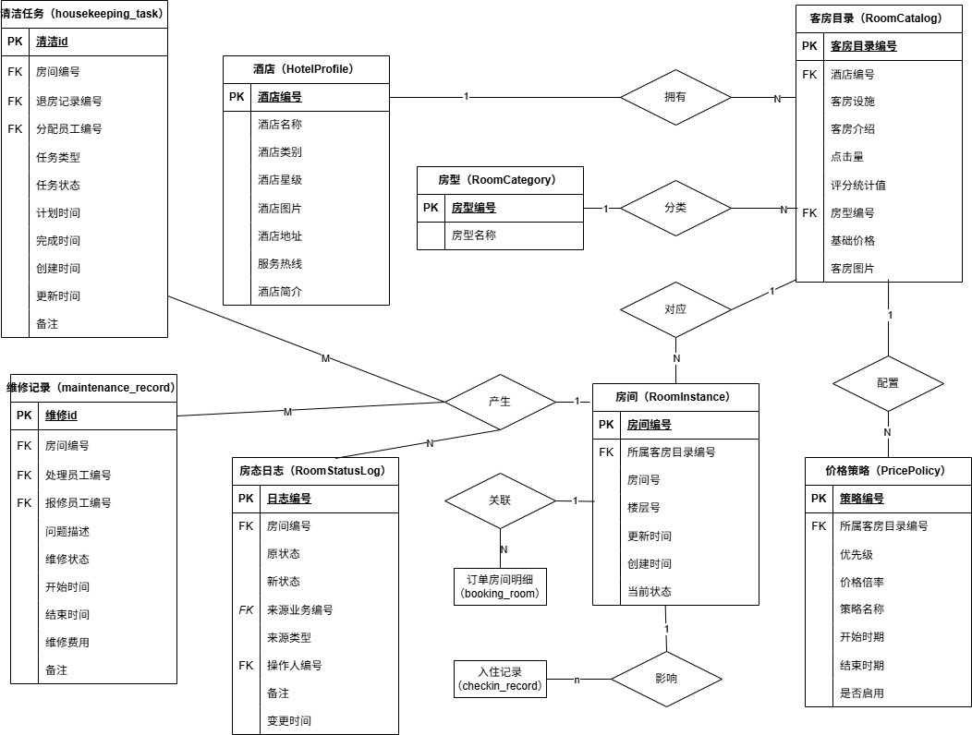图 1 客房资源管理ER图
注：其中来源业务编号 不一定只指向订单，也可能来自 booking_room、入住记录、清洁任务、维修记录等，“FK”作为逻辑外键。
4.2 预定入住
预订与入住模块主要负责客户预订、订单状态维护、员工办理入住、入住人登记以及房态同步等业务。重点围绕以下业务展开：
- 客户如何创建预订订单；
- 预订订单如何关联房间；
- 员工如何根据订单办理入住；
- 入住记录如何保存入住人信息；
- 房间状态如何随业务变化而更新。
因此，本模块主要涉及客户、预订订单、入住记录、入住人、员工和具体房间等实体。
- 客户实体（customer）
主要属性：customer_id（客户编号）customer_name（客户姓名）phone（联系电话）id_card（身份证号）register_time（注册时间）
业务说明：一个客户可以创建多个预订订单。
- 预订订单实体（booking_order）
主要属性：booking_id（预订编号）customer_id（客户编号）room_id（房间编号）checkin_date（入住日期）checkout_date（离店日期）booking_amount（预订金额）booking_status（预订状态）create_time（创建时间）
业务说明：一个预订订单对应一个客户和一个具体房间。
- 预订状态日志实体（booking_status_log）
主要属性：log_id（日志编号）booking_id（预订编号）old_status（原状态）new_status（新状态）change_time（变更时间）
业务说明：一个预订订单可以产生多条状态日志。
- 具体房间实体（room_instance）
主要属性：room_id（房间编号）room_no（房号）floor_no（楼层）room_status（房态）
业务说明：一个房间可以被多个历史订单使用。
- 入住记录实体（checkin_record）
主要属性：checkin_id（入住编号）booking_id（预订编号）room_id（房间编号）employee_id（办理员工编号）checkin_time（入住时间）checkout_time（退房时间）checkin_status（入住状态）
业务说明：一个预订订单最多生成一个入住记录。
- 入住人明细实体（checkin_guest）
用于保存实际入住人员信息。
主要属性：guest_id（明细编号）checkin_id（入住编号）guest_name（入住人姓名）guest_id_card（身份证号）guest_phone（联系电话）
业务说明：一个入住记录可以包含多个入住人。
- 员工实体（employee）
主要属性：employee_id（员工编号）employee_name（员工姓名）phone（联系电话）position（职位）
业务说明：一个员工可以办理多个入住业务。

本模块中的实体联系如下：
实体联系 | 联系类型 | 说明
customer — booking_order | 一对多 | 一个客户可创建多个订单
booking_order — booking_status_log | 一对多 | 一个订单可对应多条状态日志
room_instance — booking_order | 一对多 | 一个房间可对应多个历史订单
booking_order — checkin_record | 一对一 | 一个订单最多对应一个入住记录
checkin_record — checkin_guest | 一对多 | 一个入住记录可对应多个入住人
employee — checkin_record | 一对多 | 一个员工可办理多个入住业务
room_instance — checkin_record | 一对多 | 一个房间可产生多个入住记录
表 1 预定入住实体联系

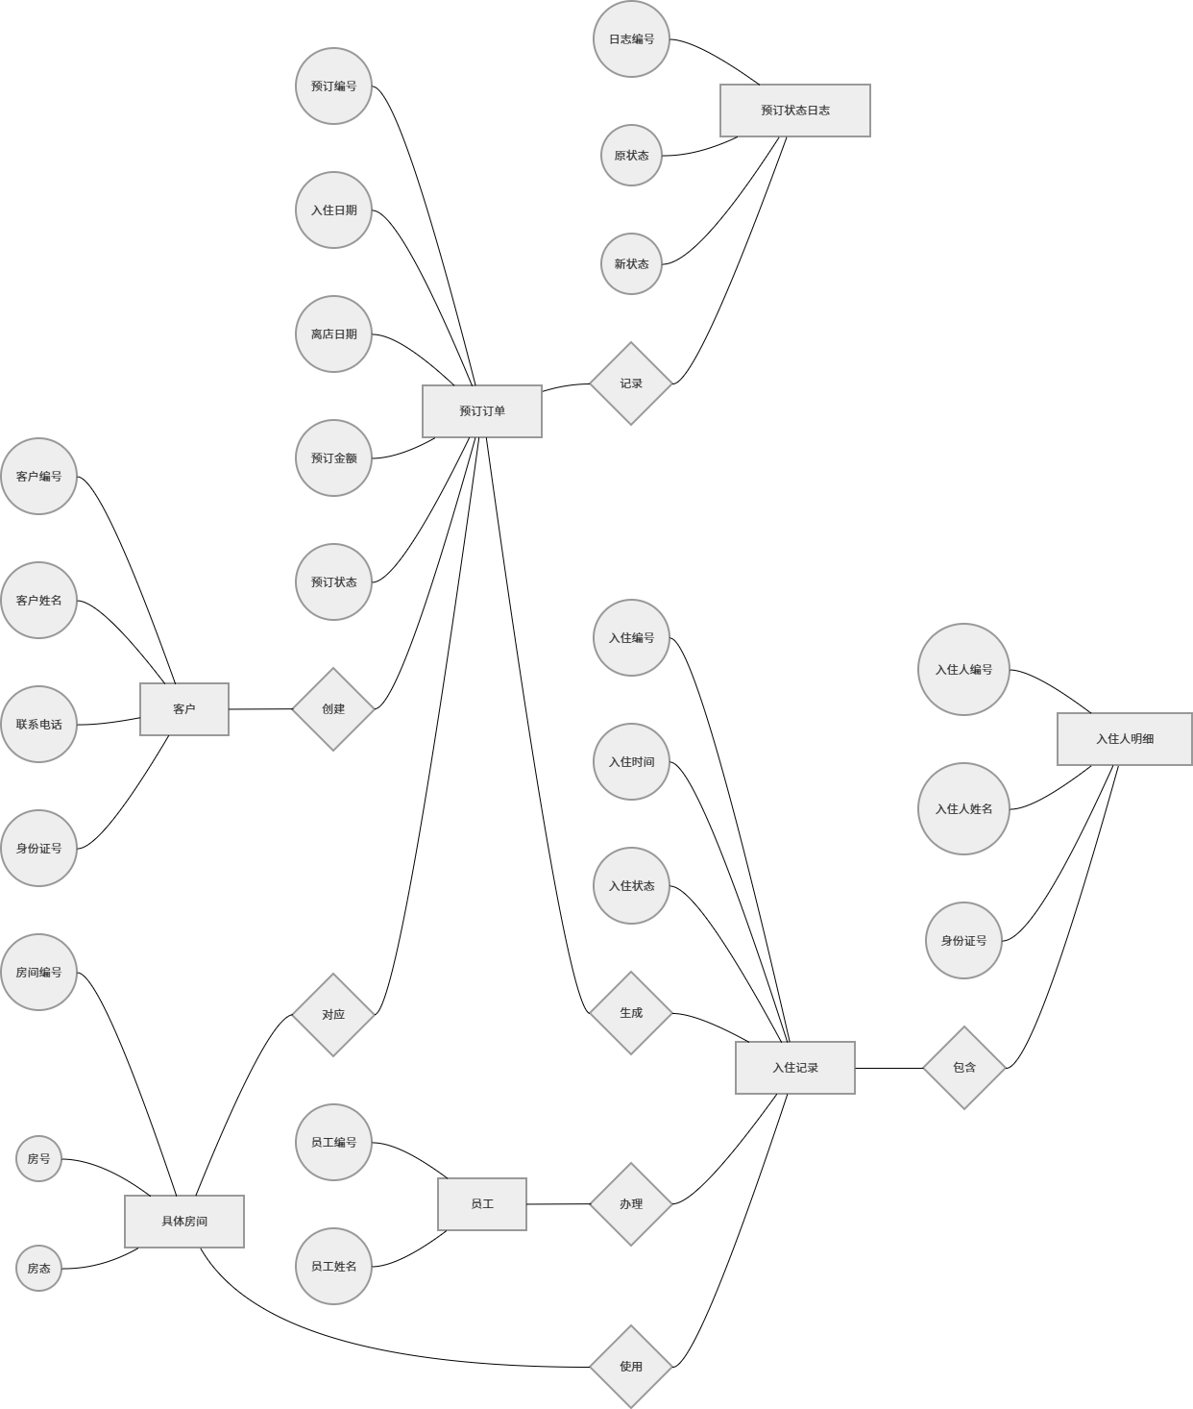
图 2 预定入住ER图

4.3 财务结算与支付退款
本局部包含的核心实体有：bill（账单）、payment_record（支付记录）、refund_record（退款记录）。它们与系统的其他核心实体 checkin_record（入住记录）和 booking_order（预订订单）存在紧密的关联。

- 账单实体
属性：账单编号、房间费用、服务费用、折扣金额、应付金额、已付金额、累计退款、账单状态、创建时间、更新时间
作用：记录客房交易的最终结算汇总信息，通过触发器动态累加支付与退款金额，实现自动化的账单状态变更与财务核销。

- 支付记录实体
属性：支付编号、支付流水号、关联账单编号、支付方式、支付金额、支付状态、备注、支付时间
作用：记录客户针对账单执行的每一笔实际缴费操作，作为支付触发器的输入源，用于驱动账单“已付金额”的更新及状态转换。

- 退款记录实体
属性：退款编号、退款流水号、关联账单编号、退款金额、退款原因、退款状态、备注、创建时间
作用：记录因订单取消或账单多付产生的资金原路返回信息，用于抵扣账单累计金额并支持财务审计与原由追溯。
关联实体 | 关联实体 | 关系类型 | 关联外键 | 业务规则描述
预订订单 | 账单 | 1 : N | 预订编号 | 一个预订订单在入住消费后可以生成一张或多张账单，但每张账单只属于一个预订订单。
入住记录 | 账单 | 1 : N | 入住编号 | 一次入住记录在退房结算时生成结算账单。账单中的预订编号和入住编号至少有一个非空。
账单 | 支付记录 | 1 : N | 账单编号 | 一张账单可通过多次支付来结清（如押金、尾款、分次刷卡）。一笔支付流水只能属于一张账单。
支付记录 | 退款记录 | 1 : N | 支付编号 | 一笔成功的支付记录在发生退款时，可以产生多次部分退款，且必须关联原支付记录以实现“原路返回”。
客户 | 账单 | 1 : N | 客户编号 | 一个客户可以拥有多张账单，但每张账单只能唯一地属于一个客户。
表 2 支付模块关联

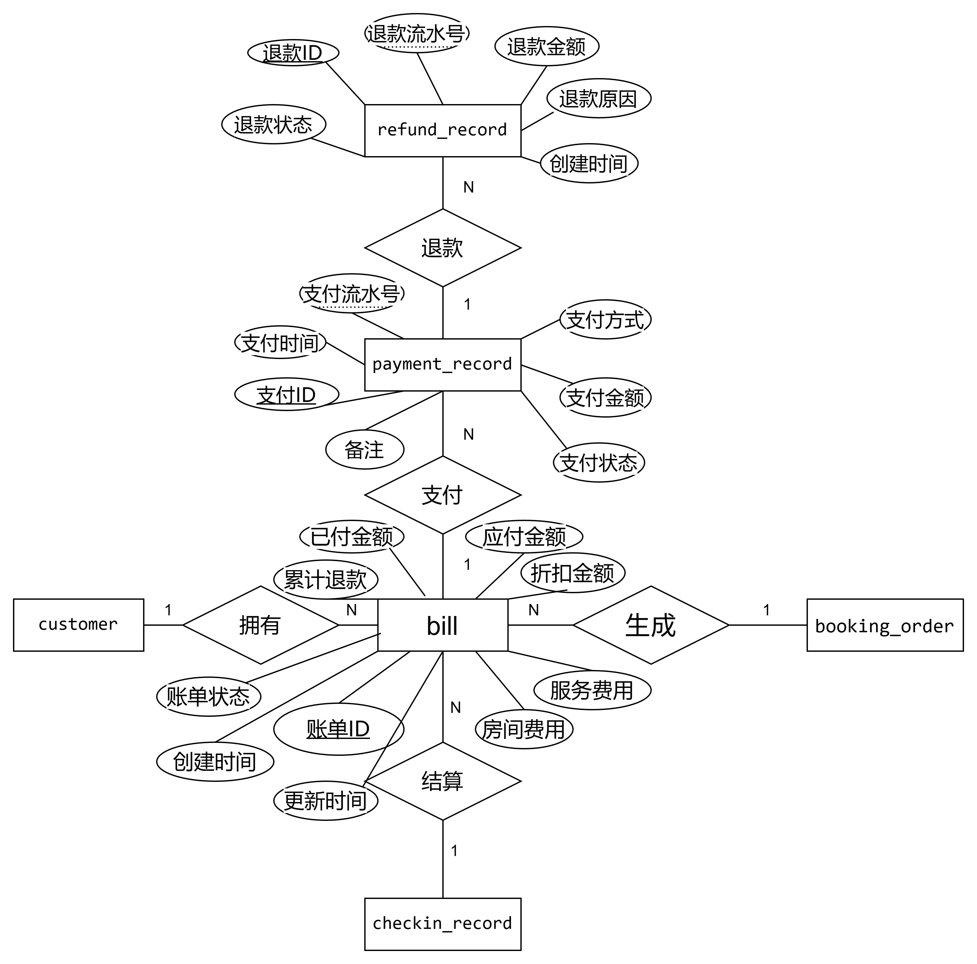
图 3 支付退款管理ER图

4.4 后台管理
- 管理员实体
实体名：管理员
属性：id、账号、密码、角色、创建时间
作用：系统最高权限管理者，负责系统配置、公告管理、数据审核。
- 员工实体
实体名：员工
属性：id、工号、姓名、密码、电话、职位、入职时间
作用：负责酒店入住办理、订单分配、客房管理、保洁维修任务派发。
- 用户实体
属性：id、账号、姓名、密码、性别、年龄、电话
作用：系统使用者，可完成注册登录、客房预订、订单支付、评价、收藏等操作。
- 评价实体（分为酒店评价、客房评价两类）
属性：id、创建时间、关联 ID、用户 ID、评论内容、管理员回复、评分
作用：记录用户对酒店与客房的评价，支持评分统计。
- 收藏实体
属性：id、用户 ID、关联 ID、关联表名、收藏名称、图片
作用：用户可收藏酒店或客房，支持快速访问。
- 操作日志实体
属性：id、操作者类型、操作者 ID、业务类型、操作行为、操作时间、备注
作用：记录管理员、员工、用户的所有关键操作，用于审计与追溯。
- 员工表现实体
属性：id、员工 ID、考核人 ID、考核开始时间、考核结束时间、入住办理数、账单开具数、支付处理数、保洁任务数、维修任务数、操作日志数、管理员评分、综合总分、绩效等级、备注、创建时间
作用：用于员工绩效考核统计，生成员工绩效报表，支撑绩效视图与存储过程。
- 登录令牌实体
属性：id、用户 ID、用户名、关联表名、角色、令牌、创建时间、过期时间
作用：用于管理员、员工、用户登录鉴权，保证系统登录安全性。
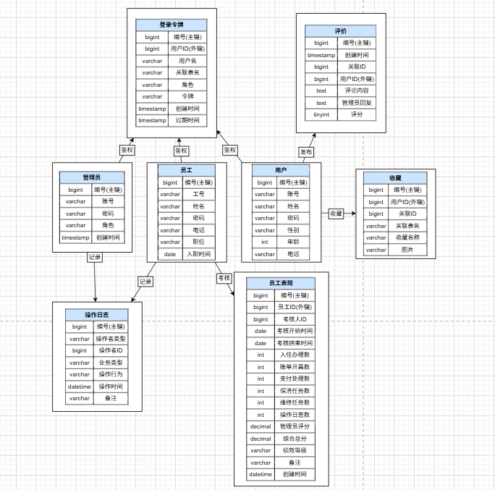
图 4 后台管理ER图
5逻辑结构设计

5.1逻辑结构设计

5.1.1客房资源管理模块
- hotel_profile (酒店信息表)
hotel_profile (id, jiudianmingcheng, leibie, xingji, jiudiandizhi)
主键 PK: id

- room_category (客房类型字典表)
room_category (id, room_category)
主键 PK: id
候选键 CK: room_category (唯一约束)

- room_catalog (客房目录表)
room_catalog (id, hotel_profile_id, room_category_id, kefangmingcheng, kefangjiage, shuliang, kefangsheshi, kefangjieshao)
主键 PK: id
外键 FK:
hotel_profile_id 引用 hotel_profile (id)，约束名 fk_catalog_hotel，级联更新(ON UPDATE CASCADE)
room_category_id 引用 room_category (id)，约束名 fk_catalog_category，级联更新(ON UPDATE CASCADE)

- room_instance (实体房间表)
room_instance (id, room_catalog_id, room_no, floor_no, status)
主键 PK: id
候选键 CK: room_no (唯一约束)
外键 FK: room_catalog_id 引用 room_catalog (id)，约束名 fk_room_instance_catalog，级联更新(ON UPDATE CASCADE)

- price_policy (价格策略表)
price_policy (id, room_catalog_id, policy_name, start_date, end_date, price_multiplier, priority)
主键 PK: id
外键 FK: room_catalog_id 引用 room_catalog (id)，
约束名 fk_price_policy_catalog，级联更新与删除(ON UPDATE CASCADE, ON DELETE CASCADE)

- room_status_log (房态变更日志表)
room_status_log (id, room_id, old_status, new_status, source_type, source_id, remark)
主键 PK: id
外键 FK: room_id 引用 room_instance (id)，约束名 fk_status_log_room，删除时置空(ON DELETE SET NULL)

- booking_order (预订主单表)
booking_order (id, customer_id, room_catalog_id, room_instance_id, expected_checkin_date, expected_checkout_date, booking_status)
主键 PK: id
外键 FK:
customer_id 逻辑引用 customer (id)，由应用层保证完整性
room_catalog_id 引用 room_catalog (id)，约束名 fk_booking_catalog
room_instance_id 引用 room_instance (id)，约束名 fk_booking_room_instance

- booking_room (订单房间明细表)
booking_room (id, booking_id, room_id, room_price, room_status)
主键 PK: id
候选键 CK: (booking_id, room_id) 联合唯一
外键 FK:
booking_id 引用 booking_order (id)，约束名 fk_booking_room_order，级联删除
room_id 引用 room_instance (id)，约束名 fk_booking_room_detail

- housekeeping_task (清扫任务表)
housekeeping_task (id, room_id, checkin_id, assigned_employee_id, task_type, task_status, scheduled_time, completed_time)
主键 PK: id
外键 FK:
room_id 引用 room_instance (id)，约束名 fk_task_room
checkin_id 逻辑引用 checkin_record (id)
assigned_employee_id 逻辑引用 employee (id)

- maintenance_record (维修记录表)
maintenance_record (id, room_id, reported_by_employee_id, handled_by_employee_id, issue_desc, maintenance_status, start_time, end_time, cost_amount)
主键 PK: id
外键 FK: room_id 引用 room_instance (id)，约束名 fk_maintenance_room
可以大致分为三层：
1）酒店与房型基础层：`hotel_profile`、`room_category`
2）客房定义与资源层：`room_catalog`、`room_instance`、`price_policy`
3）房态联动与过程层：`room_status_log`、`booking_order`、`booking_room`、`housekeeping_task`、`maintenance_record`

5.1.2预定入住模块
- customer（客户表）
customer(customer_id, customer_name, phone, id_card, register_time)
主键 PK: customer_id
- room_instance（具体房间表）
room_instance(room_id, room_no, floor_no, room_status)
主键 PK: room_id
- booking_order（预订订单表）
booking_order(booking_id, customer_id, room_id, checkin_date, checkout_date, booking_amount, booking_status, create_time)
主键 PK: booking_id
- booking_status_log（预订状态日志表）
booking_status_log(log_id, booking_id, old_status, new_status, change_time)
主键 PK: log_id
- employee（员工表）
employee(employee_id, employee_name, phone, position)
主键 PK: employee_id
- checkin_record（入住记录表）
checkin_record(checkin_id, booking_id, room_id, employee_id, checkin_time, checkout_time, checkin_status)
主键 PK: checkin_id
- checkin_guest（入住人明细表）
checkin_guest(guest_id, checkin_id, guest_name, guest_id_card, guest_phone)
主键 PK: guest_id

5.1.3财务结算支付退款模块
- bill (账单信息表)
bill (id, booking_id, checkin_id, customer_id, room_amount， service_amount， discount_amount， payable_amount, paid_amount, refund_amount, status， created_at， updated_at)
主键 PK: id
外键 FK:
booking_id 引用 booking_order (id)，约束名 fk_bill_booking，删除时置空(ON DELETE SET NULL)
checkin_id 引用 checkin_record (id)，约束名 fk_bill_checkin，删除时置空(ON DELETE SET NULL)
customer_id 当前版本未添加物理外键约束，但逻辑上引用 customer (id)，由应用层保证参照完整性
业务规则：payable_amount = room_amount + service_amount - discount_amount。paid_amount 不能超过 payable_amount。

- payment_record (支付记录表)
payment_record (id, bill_id, payment_no, pay_method, pay_amount, pay_status, paid_at， remark)
主键 PK: id
候选键 CK: payment_no
外键 FK: 外键 FK: bill_id 引用 bill (id)，约束名 fk_payment_record_bill，级联更新与删除(ON UPDATE CASCADE, ON DELETE CASCADE)

- refund_record (退款记录表)
refund_record (id, payment_id, refund_no, refund_amount, refund_reason, refund_status， created_at)
主键 PK: id
候选键 CK: refund_no
外键 FK: payment_id 引用 payment_record (id)，
约束名 fk_refund_record_payment，级联更新与删除(ON UPDATE CASCADE, ON DELETE CASCADE)

5.1.4后台管理模块
- admin_user (管理员表)
admin_user (id, username, password, role, addtime)
主键 PK: id

- employee (员工表)
employee (id, employeegonghao, employeexingming, mima, lianxidianhua, zhiwei, addtime)
主键 PK: id
候选键 CK: employeegonghao

- customer (客户表)
customer (id, customerming, xingming, mima, xingbie, nianling, shoujihao, addtime)
主键 PK: id
候选键 CK: customerming

- hotel_profile (酒店简介表)
hotel_profile (id, jiudianmingcheng, leibie, xingji, jiudiantupian, jiudiandizhi, fuwurexian, jiudianjieshao, addtime)
主键 PK: id

- hotel_review (酒店评论表)
hotel_review (id, refid, userid, nickname, content, reply, score, addtime)
主键 PK: id

- room_review (客房评论表)
room_review (id, refid, userid, nickname, content, reply, score, addtime)
主键 PK: id

- favorite (收藏表)
favorite (id, userid, refid, tablename, name, picture, addtime)
主键 PK: id

- notice (公告表)
notice (id, title, content, picture, addtime)
主键 PK: id

- system_config (系统配置表)
system_config (id, name, value)
主键 PK: id

- operation_log (操作日志表)
operation_log (id, operator_type, operator_id, business_type, action, remark, created_at)
主键 PK: id

- auth_token (认证令牌表)
auth_token (id, userid, username, tablename, role, auth_token, addtime, expiratedtime)
主键 PK: id

- employee_performance (员工绩效表)
employee_performance (id, employee_id, assessor_id, period_start, period_end, checkin_count, bill_count, payment_count, cleaning_count, maintenance_count, operation_count, manager_score, total_score, grade, remark, created_at)
主键 PK: id
候选键 CK: employee_id, period_start, period_end
外键 FK: employee_id 引用 employee (id)，
约束名 fk_employee_performance_employee，级联更新与删除(ON UPDATE CASCADE, ON DELETE CASCADE)
外键 FK: assessor_id 引用 employee (id)，
约束名 fk_employee_performance_assessor，级联更新、删除置空(ON UPDATE CASCADE, ON DELETE SET NULL)

5.2模式优化
5.2.1 客房资源管理模块
1.如果直接把客房名称、房型等字段全部放进一张表，会造成明显的数据冗余。例如同一种房型下的多间房间会重复保存同样的客房名称、图片、介绍、设施和基础价格。一旦房型基础价格调整，就需要修改多行数据，容易产生更新异常。因此当前设计将其拆分为：
`room_catalog`：描述“卖什么房”`room_instance`：描述“具体哪一间房”
这样可以使客房目录信息只保存一次，实体房间通过外键引用目录主键
2.如果只在 `room_instance` 中保存当前状态，那么虽然能知道房间现在是否可用，但无法回答“为什么变成这个状态”“由谁操作”“何时发生变更”等问题。因此系统将房态控制拆为两层：
`room_instance.status` 保存当前房态 `room_status_log` 保存状态变更历史
3. 本模块主要关系模式均可认为至少达到第三范式。
关系模式 | 关键函数依赖 | 规范化说明
hotel_profile | id->酒店名称、类别、星级、地址... | 非主属性完全依赖主键，无传递依赖
room_category | id->room_category，room_category->id | 类型字典表，满足3NF
room_catalog | id->客房目录描述信息 | 房型描述依赖目录主键，酒店与房型通过外键关联，避免把基础实体信息混入本表
room_instance | id->room_catalog_id,room_no,floor_no,status...，room_no->id | 当前房态依赖实体房间主键，无部分依赖
price_policy | id->room_catalog_id,起止日期,价格倍率... | 价格策略独立存放，避免重复写入客房表
room_status_log | id->room_id,old_status,new_status,source_type... | 每条日志唯一表示一次变更，满足3NF
booking_order | id->customer_id,room_catalog_id,expected_checkin_date... | 主单负责订单头信息，不再承载多房间明细
booking_room | id->booking_id,room_id,room_price,stay_start_date... | 房间明细只依赖本明细主键
housekeeping_task | id->room_id,task_type,task_status... | 清扫任务独立管理，消除“房态=清扫中”场景中的附加描述冗余
maintenance_record | id->room_id,issue_desc,maintenance_status... | 维修业务独立建表，消除维修描述与房态字段耦合
表 3 客房资源管理模块关系模式
5.2.2 预定与入住模块
（1）第一范式（1NF）
所有字段均为原子属性，不存在重复组。
例如：一个入住人对应一条入住记录；一个联系电话只保存一个号码。
因此满足第一范式。
（2）第二范式（2NF）
所有非主属性完全依赖于主键。
例如：booking_id → customer_id, room_id, booking_amount所有字段均依赖于 booking_id。
因此满足第二范式。
（3）第三范式（3NF）
不存在非主属性对主键的传递依赖。
例如：客户联系电话仅保存在 customer 表；房态仅保存在 room_instance 表。
因此满足第三范式。
表名 | 主键 | 外键
customer | customer_id | 无
booking_order | booking_id | customer_id、room_id
booking_status_log | log_id | booking_id
checkin_record | checkin_id | booking_id、room_id、employee_id
checkin_guest | guest_id | checkin_id
表 4 预定与入住主键与外键设计

5.2.3 财务结算与支付退款模块
- bill 关系模式优化分析
函数依赖：
id → booking_id, checkin_id, customer_id, room_amount， service_amount， discount_amount， payable_amount, paid_amount, refund_amount, status
非主属性依赖分析：所有非主属性（如金额、状态等）都完全函数依赖于主键 id，不依赖于其他非主属性。
传递依赖检查：payable_amount 是由 room_amount + service_amount - discount_amount 计算得出，这是一种计算依赖，但在数据库设计中作为冗余字段存储以提高查询性能。
结论：此关系模式不存在部分或传递依赖，直接满足 3NF 和 BCNF。

- payment_record 关系模式优化分析
函数依赖：
id → payment_no, bill_id, pay_method, pay_amount, pay_status, paid_at
payment_no → id, bill_id, pay_method, pay_amount, pay_status, paid_at （候选键）
分析：不包含部分依赖或传递依赖。
结论：满足 3NF 和 BCNF。

- refund_record 关系模式优化分析
函数依赖：
id → payment_id, refund_no, refund_amount, refund_reason, refund_status
refund_no → id, payment_id, refund_amount, refund_reason, refund_status （候选键）
分析：不包含部分依赖或传递依赖。
结论：满足 3NF 和 BCNF。
5.2.4 后台管理模块

- 所有表均有唯一主键，无部分依赖与传递依赖。
- 酒店、客房、评价、订单、用户完全分离，消除冗余。
- 使用外键建立关联，保证数据一致性。
- 评价、收藏、日志统一设计，可扩展、易维护。
- 所有字段原子性强，无复合属性。
- 新增员工绩效表、登录令牌表，均满足第三范式，无冗余字段，主键唯一，外键关联对应主表。
- 登录令牌通过tablename区分管理员 / 员工 / 用户，实现多角色统一鉴权。

5.3表关系图

5.3.1 客房资源管理模块
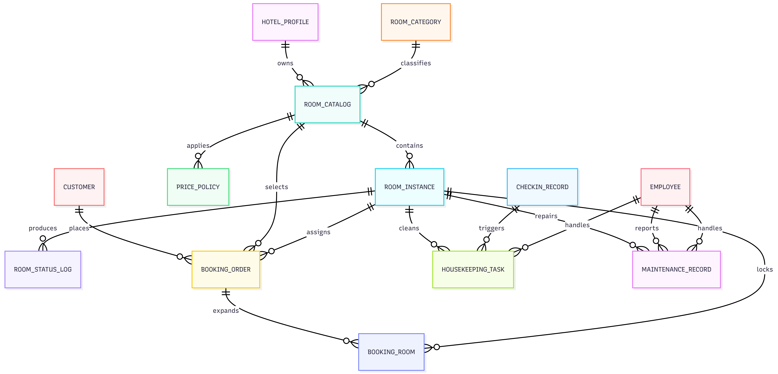
图 5 客房资源管理模块主要外键依赖关系
主要依赖关系：
- room_catalog（客房目录表）的外键依赖：
room_catalog 通过 hotel_profile_id、room_category_id 关联酒店档案和客房类型。对应约束为 fk_room_catalog_hotel_profile、fk_room_catalog_room_category，删除规则均为 ON DELETE RESTRICT，防止已使用的酒店或房型被删除。

- room_instance（实体房间表）的外键依赖：
room_instance 通过 room_catalog_id 关联 room_catalog。对应约束为 fk_room_instance_catalog，删除规则为 ON DELETE RESTRICT，保证已有实体房间时不能删除客房目录。

- price_policy（房价策略表）的外键依赖：
price_policy 通过 room_catalog_id 关联 room_catalog。对应约束为 fk_price_policy_catalog，删除规则为 ON DELETE CASCADE，删除客房目录时同步删除价格策略。

- room_status_log（房态变更日志表）的外键依赖：
room_status_log 通过 room_id 关联 room_instance。对应约束为 fk_room_status_log_room，删除规则为 ON DELETE CASCADE，删除实体房间时同步删除房态日志。

- 客房业务使用关系：
booking_order、booking_room、checkin_record、housekeeping_task、maintenance_record 均通过 room_catalog_id 或 room_id 关联客房资源。其中订单表多采用 ON DELETE SET NULL 保留业务记录，入住、保洁、维修等直接占用房间的记录多采用 ON DELETE RESTRICT，防止删除正在被业务引用的实体房间。
5.3.2入住与预定模块
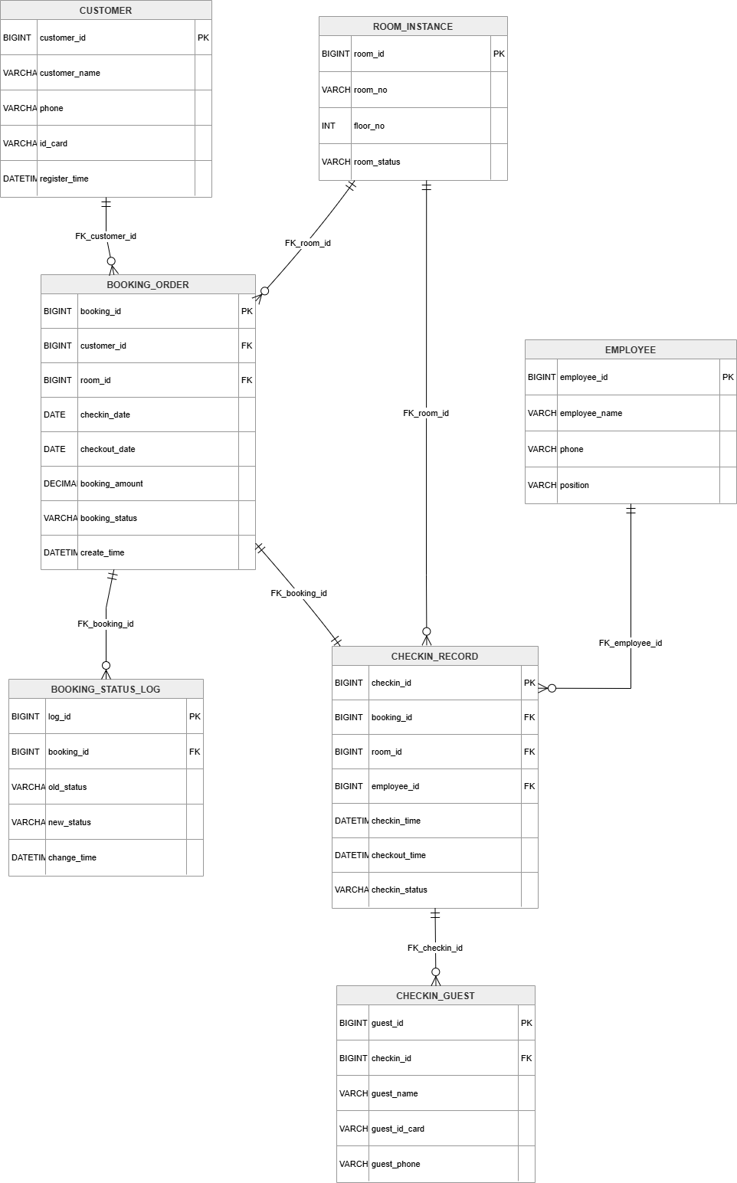
图 6 预定与入住模块PDM

5.3.3财务结算支付退款模块
- bill (账单表) 的外键依赖：
bill 通过 booking_id 和 checkin_id 追溯业务来源。对应的物理约束为 fk_bill_booking 和 fk_bill_checkin，删除规则均为 ON DELETE SET NULL。即删除预订订单或入住记录时，账单记录保留，外键字段置为 NULL，保护财务数据不丢失。customer_id 在逻辑上关联客户，但当前版本未建立物理外键约束，由应用层维护一致性。
- payment_record (支付记录表) 的外键依赖：
bill_id 通过约束 fk_payment_record_bill 引用 bill 表，规则为 ON UPDATE CASCADE 和 ON DELETE CASCADE（删除账单时支付记录级联删除）。
- refund_record (退款记录表) 的外键依赖：
payment_id 通过约束 fk_refund_record_payment 引用 payment_record 表，同样采用级联更新和删除。

5.3.4后台管理模块
- 员工、管理员与操作日志
employee与operation_log：一个员工可以产生多条操作日志，operation_log.operator_id关联employee.id，用于绩效统计和操作追溯。
admin_user与operation_log：一个管理员可以产生多条操作日志，operation_log.operator_id关联admin_user.id。
- 评价相关依赖
hotel_profile与hotel_review：一个酒店可以拥有多条酒店评价记录，hotel_review.refid关联hotel_profile.id。评价提交后通过触发器更新hotel_profile中的review_count和avg_score。
room_catalog与room_review：一个客房目录可以拥有多条客房评价记录，room_review.refid关联room_catalog.id。评价提交后通过触发器更新room_catalog中的review_count和avg_score。
- 收藏依赖
customer与favorite：一个客户可以收藏多个酒店或客房对象，favorite.userid关联customer.id。
- 公告与系统配置
notice和system_config为独立辅助表，不依赖其他业务主表，由管理员单独维护。
- 员工与员工表现
employee (1) —— 一对多 —— employee_performance (N)
一个员工可有多条绩效考核记录，employee_performance.employee_id 关联 employee.id；管理员可作为考核人，assessor_id 关联 admin_user.id。
- 登录令牌关联
admin_user/employee/customer (1) —— 一对多 —— auth_token (N)
管理员、员工、用户均可生成多条登录令牌，auth_token.userid 关联对应用户主键，tablename区分用户类型。

6表的设计实现

6.1表结构数据字典描述
表名 | 中文含义 | 主要字段 | 主键/候选键 | 完整性约束及说明
system_config | 系统配置表 | id, name, value | PK: id | 保存首页轮播、图片等配置参数，name 为配置项名称。
admin_user | 管理员表 | id, username, password, role, addtime | PK: id | 管理员账号信息，role 默认 admin。
customer | 用户表 | id, addtime, customerming, xingming, mima, xingbie, nianling, shoujihao | PK: id；UK: customerming | 客户登录名唯一，供预订、收藏、评价、账单等业务引用。
employee | 员工表 | id, addtime, employeegonghao, employeexingming, mima, xingbie, lianxidianhua, touxiang, ruzhishijian, zhiwei | PK: id；UK: employeegonghao | 员工工号唯一，供入住办理、保洁、维修、绩效统计和操作日志引用。
auth_token | 认证令牌表 | id, userid, username, tablename, role, auth_token, addtime, expiratedtime | PK: id | tablename 区分管理员、员工和用户，记录登录令牌及过期时间。
hotel_profile | 酒店简介表 | id, addtime, jiudianmingcheng, leibie, xingji, jiudiantupian, jiudiandizhi, fuwurexian, jiudianjieshao, review_count, avg_score | PK: id | 酒店基础资料；评论触发器维护 review_count 与 avg_score。
hotel_review | 酒店评论表 | id, addtime, refid, userid, nickname, content, reply, score | PK: id | refid 逻辑关联 hotel_profile.id；新增评论后触发器回写酒店评分。
room_category | 客房类型表 | id, addtime, room_category | PK: id；UK: room_category | 房型字典表，避免房型名称重复录入。
room_catalog | 酒店客房目录表 | id, addtime, kefangmingcheng, room_category, kefangtupian, kefangjiage, shuliang, jiudianmingcheng, jiudiandizhi, kefangsheshi, kefangjieshao, clicknum, hotel_profile_id, room_category_id, review_count, avg_score | PK: id；FK: hotel_profile_id, room_category_id | 描述可销售房型；外键关联酒店和房型，评论触发器维护评分统计。
room_review | 客房评论表 | id, addtime, refid, userid, nickname, content, reply, score | PK: id | refid 逻辑关联 room_catalog.id；新增评论后触发器回写客房评分。
room_instance | 实体房间表 | id, room_catalog_id, room_no, floor_no, status, created_at, updated_at | PK: id；UK: room_no；FK: room_catalog_id | 记录每一间实体房间；status 包含 available、reserved、occupied、cleaning、maintenance。
price_policy | 价格策略表 | id, room_catalog_id, policy_name, start_date, end_date, price_multiplier, priority, enabled | PK: id；FK: room_catalog_id | 按日期区间和优先级维护房价倍率，删除客房目录时级联删除策略。
booking_order | 客房预订主单表 | id, addtime, yudingbianhao, kefangmingcheng, room_category, kefangjiage, shuliang, zongjine, customer_id, room_catalog_id, expected_checkin_date, expected_checkout_date, booking_status, room_instance_id | PK: id；UK: yudingbianhao；FK: customer_id, room_catalog_id, room_instance_id | 记录预订主信息；状态变更写入日志，取消订单时释放已锁定房间。
booking_room | 订单房间明细表 | id, booking_id, room_id, room_price, stay_start_date, stay_end_date, room_status, created_at | PK: id；UK: booking_id+room_id；FK: booking_id, room_id | 解决一个订单预订多间实体房间的问题；插入明细时触发器锁定房态。
booking_status_log | 预订状态日志表 | id, booking_id, old_status, new_status, operator_id, remark, created_at | PK: id；FK: booking_id | 记录订单创建、入住、取消、完成等状态流转过程。
checkin_assignment | 入住安排表 | id, addtime, yudingbianhao, jiudianmingcheng, fangjianleixing, shuliang, customerming, xingming, shoujihao, fangjianhao, crossuserid, crossrefid | PK: id | 保留原系统入住安排数据，作为升级前业务数据兼容表。
checkin_record | 入住记录表 | id, booking_id, room_id, customer_id, employee_id, checkin_time, checkout_time, status, remark | PK: id；FK: booking_id, room_id, customer_id, employee_id | 办理入住时占用房间；退房时改为待清扫并生成清扫任务。
checkin_guest | 入住人明细表 | id, checkin_id, guest_name, id_card_no, phone, is_primary, created_at | PK: id；FK: checkin_id | 一条入住记录可对应多个入住人，删除入住记录时级联删除明细。
bill | 账单表 | id, booking_id, checkin_id, customer_id, room_amount, service_amount, discount_amount, payable_amount, paid_amount, refund_amount, status, created_at, updated_at | PK: id；FK: booking_id, checkin_id | 账单至少可追溯到预订或入住；支付、退款触发器维护 paid_amount、refund_amount 和 status。
payment_record | 支付记录表 | id, bill_id, payment_no, pay_method, pay_amount, pay_status, paid_at, remark | PK: id；UK: payment_no；FK: bill_id | 记录每次支付流水；成功支付后触发器更新账单实付金额。
refund_record | 退款记录表 | id, payment_id, refund_no, refund_amount, refund_reason, refund_status, created_at | PK: id；UK: refund_no；FK: payment_id | 记录退款流水；成功退款后触发器汇总退款金额并更新账单状态。
favorite | 收藏表 | id, addtime, userid, refid, tablename, name, picture, type, inteltype | PK: id | userid 逻辑关联客户，tablename 与 refid 指向被收藏的酒店或客房
notice | 酒店公告表 | id, addtime, title, introduction, picture, content | PK: id | 管理员维护公告内容和展示图片。
operation_log | 操作日志表 | id, operator_type, operator_id, business_type, business_id, action, remark, created_at | PK: id | 统一记录系统、客户、员工、管理员的关键操作，支撑审计和绩效统计。
room_status_log | 房态变更日志表 | id, room_id, old_status, new_status, source_type, source_id, operator_id, remark, created_at | PK: id；FK: room_id | 记录房态变化来源，可追溯预订、入住、保洁和维修导致的状态变更。
housekeeping_task | 保洁任务表 | id, room_id, checkin_id, assigned_employee_id, task_type, task_status, scheduled_time, completed_time, remark, created_at, updated_at | PK: id；FK: room_id, checkin_id, assigned_employee_id | 退房、维修完成或人工创建保洁任务；完成后触发器释放房间为空闲。
maintenance_record | 维修记录表 | id, room_id, reported_by_employee_id, handled_by_employee_id, issue_desc, maintenance_status, start_time, end_time, cost_amount, remark | PK: id；FK: room_id, reported_by_employee_id, handled_by_employee_id | 报修时触发器将房态置为维修；维修完成后转为待清扫并生成保洁任务。
employee_performance | 员工绩效表 | id, employee_id, assessor_id, period_start, period_end, checkin_count, bill_count, payment_count, cleaning_count, maintenance_count, operation_count, manager_score, total_score, grade, remark, created_at | PK: id；UK: employee_id+period_start+period_end；FK: employee_id, assessor_id | 按考核周期记录员工业务量和评分结果，支持绩效统计。
表 5 表结构数据字典
其中，系统中所有业务主表均设置自增主键；客户登录名、员工工号、房间号、预订编号、支付流水号、退款流水号等具有业务唯一性的字段设置唯一约束；可被历史数据引用的业务表在删除规则上多采用 RESTRICT 或 SET NULL，以避免误删造成订单、账单和日志丢失。
复杂完整性主要通过触发器实现：预订或订单房间明细生成后锁定房态，取消预订释放房间；入住后房态置为 occupied，退房后置为 cleaning 并生成保洁任务；维修上报后置为 maintenance，维修完成后转入清扫；支付与退款触发器自动回写账单金额和状态；酒店、客房评论触发器维护评价数量和平均分。

6.2表的创建
- 基础表与优化后业务表创建脚本
CREATE TABLE IF NOT EXISTS `system_config` (
`id` bigint NOT NULL AUTO_INCREMENT COMMENT '主键',
`name` varchar(100) NOT NULL COMMENT '配置参数名称',
`value` varchar(100) DEFAULT NULL COMMENT 'config value',
PRIMARY KEY (`id`)
) ENGINE=InnoDB AUTO_INCREMENT=4 DEFAULT CHARSET=utf8mb4 COMMENT='配置文件';

CREATE TABLE IF NOT EXISTS `hotel_review` (
`id` bigint NOT NULL AUTO_INCREMENT COMMENT '主键',
`addtime` timestamp NOT NULL DEFAULT CURRENT_TIMESTAMP COMMENT '创建时间',
`refid` bigint NOT NULL COMMENT '关联表id',
`userid` bigint NOT NULL COMMENT '用户id',
`nickname` varchar(200) DEFAULT NULL COMMENT 'username',
`content` longtext NOT NULL COMMENT '评论内容',
`reply` longtext COMMENT '回复内容',
PRIMARY KEY (`id`)
) ENGINE=InnoDB AUTO_INCREMENT=1108 DEFAULT CHARSET=utf8mb4 COMMENT='酒店简介评论表';

CREATE TABLE IF NOT EXISTS `room_review` (
`id` bigint NOT NULL AUTO_INCREMENT COMMENT '主键',
`addtime` timestamp NOT NULL DEFAULT CURRENT_TIMESTAMP COMMENT '创建时间',
`refid` bigint NOT NULL COMMENT '关联表id',
`userid` bigint NOT NULL COMMENT '用户id',
`nickname` varchar(200) DEFAULT NULL COMMENT 'username',
`content` longtext NOT NULL COMMENT '评论内容',
`reply` longtext COMMENT '回复内容',
PRIMARY KEY (`id`)
) ENGINE=InnoDB AUTO_INCREMENT=1208 DEFAULT CHARSET=utf8mb4 COMMENT='legacy table';

CREATE TABLE IF NOT EXISTS `hotel_profile` (
`id` bigint NOT NULL AUTO_INCREMENT COMMENT '主键',
`addtime` timestamp NOT NULL DEFAULT CURRENT_TIMESTAMP COMMENT '创建时间',
`jiudianmingcheng` varchar(200) NOT NULL COMMENT '酒店名称',
`leibie` varchar(200) NOT NULL COMMENT '类别',
`xingji` varchar(200) NOT NULL COMMENT '星级',
`jiudiantupian` varchar(200) DEFAULT NULL COMMENT '酒店图片',
`jiudiandizhi` varchar(200) DEFAULT NULL COMMENT '酒店地址',
`fuwurexian` varchar(200) DEFAULT NULL COMMENT '服务热线',
`jiudianjieshao` longtext COMMENT '酒店介绍',
PRIMARY KEY (`id`)
) ENGINE=InnoDB AUTO_INCREMENT=1002 DEFAULT CHARSET=utf8mb4 COMMENT='legacy table';

CREATE TABLE IF NOT EXISTS `room_catalog` (
`id` bigint NOT NULL AUTO_INCREMENT COMMENT '主键',
`addtime` timestamp NOT NULL DEFAULT CURRENT_TIMESTAMP COMMENT '创建时间',
`kefangmingcheng` varchar(200) NOT NULL COMMENT '客房名称',
`room_category` varchar(200) NOT NULL COMMENT '客房类型',
`kefangtupian` varchar(200) NOT NULL COMMENT '客房图片',
`kefangjiage` float NOT NULL COMMENT '客房价格',
`shuliang` int DEFAULT NULL COMMENT '数量',
`jiudianmingcheng` varchar(200) DEFAULT NULL COMMENT '酒店名称',
`jiudiandizhi` varchar(200) DEFAULT NULL COMMENT '酒店地址',
`kefangsheshi` longtext COMMENT '客房设施',
`kefangjieshao` longtext COMMENT '客房介绍',
`clicknum` int DEFAULT '0' COMMENT '点击次数',
PRIMARY KEY (`id`)
) ENGINE=InnoDB AUTO_INCREMENT=3008 DEFAULT CHARSET=utf8mb4 COMMENT='酒店客房';

CREATE TABLE IF NOT EXISTS `room_category` (
`id` bigint NOT NULL AUTO_INCREMENT COMMENT '主键',
`addtime` timestamp NOT NULL DEFAULT CURRENT_TIMESTAMP COMMENT '创建时间',
`room_category` varchar(200) NOT NULL COMMENT '客房类型',
PRIMARY KEY (`id`),
UNIQUE KEY `room_category` (`room_category`)
) ENGINE=InnoDB AUTO_INCREMENT=2008 DEFAULT CHARSET=utf8mb4 COMMENT='客房类型';

CREATE TABLE IF NOT EXISTS `booking_order` (
`id` bigint NOT NULL AUTO_INCREMENT COMMENT '主键',
`addtime` timestamp NOT NULL DEFAULT CURRENT_TIMESTAMP COMMENT '创建时间',
`yudingbianhao` varchar(200) DEFAULT NULL COMMENT '预定编号',
`kefangmingcheng` varchar(200) NOT NULL COMMENT '客房名称',
`room_category` varchar(200) NOT NULL COMMENT '客房类型',
`kefangjiage` float NOT NULL COMMENT '客房价格',
`shuliang` int DEFAULT NULL COMMENT '数量',
`zongjine` float DEFAULT NULL COMMENT 'total amount',
`kefangtupian` varchar(200) DEFAULT NULL COMMENT '客房图片',
`jiudianmingcheng` varchar(200) DEFAULT NULL COMMENT '酒店名称',
`jiudiandizhi` varchar(200) DEFAULT NULL COMMENT '酒店地址',
`customerming` varchar(200) DEFAULT NULL COMMENT 'username',
`xingming` varchar(200) DEFAULT NULL COMMENT '姓名',
`shoujihao` varchar(200) DEFAULT NULL COMMENT 'mobile phone',
`yudingriqi` date DEFAULT NULL COMMENT '预定日期',
`ispay` varchar(200) DEFAULT 'unpaid' COMMENT 'payment status',
PRIMARY KEY (`id`),
UNIQUE KEY `yudingbianhao` (`yudingbianhao`)
) ENGINE=InnoDB AUTO_INCREMENT=6008 DEFAULT CHARSET=utf8mb4 COMMENT='客房预定';

CREATE TABLE IF NOT EXISTS `notice` (
`id` bigint NOT NULL AUTO_INCREMENT COMMENT '主键',
`addtime` timestamp NOT NULL DEFAULT CURRENT_TIMESTAMP COMMENT '创建时间',
`title` varchar(200) NOT NULL COMMENT '标题',
`introduction` longtext COMMENT 'introduction',
`picture` varchar(200) NOT NULL COMMENT '图片',
`content` longtext NOT NULL COMMENT '内容',
PRIMARY KEY (`id`)
) ENGINE=InnoDB AUTO_INCREMENT=93 DEFAULT CHARSET=utf8mb4 COMMENT='酒店公告';

CREATE TABLE IF NOT EXISTS `checkin_assignment` (
`id` bigint NOT NULL AUTO_INCREMENT COMMENT '主键',
`addtime` timestamp NOT NULL DEFAULT CURRENT_TIMESTAMP COMMENT '创建时间',
`yudingbianhao` varchar(200) DEFAULT NULL COMMENT '预定编号',
`jiudianmingcheng` varchar(200) NOT NULL COMMENT '酒店名称',
`fangjianleixing` varchar(200) NOT NULL COMMENT '房间类型',
`shuliang` float DEFAULT NULL COMMENT '数量',
`kefangtupian` varchar(200) DEFAULT NULL COMMENT '客房图片',
`customerming` varchar(200) DEFAULT NULL COMMENT 'username',
`xingming` varchar(200) DEFAULT NULL COMMENT '姓名',
`shoujihao` varchar(200) DEFAULT NULL COMMENT 'mobile phone',
`fangjianhao` varchar(200) DEFAULT NULL COMMENT 'room number',
`crossuserid` bigint DEFAULT NULL COMMENT '跨表用户id',
`crossrefid` bigint DEFAULT NULL COMMENT '跨表主键id',
PRIMARY KEY (`id`)
) ENGINE=InnoDB AUTO_INCREMENT=78 DEFAULT CHARSET=utf8mb4 COMMENT='入住安排';

CREATE TABLE IF NOT EXISTS `favorite` (
`id` bigint NOT NULL AUTO_INCREMENT COMMENT '主键',
`addtime` timestamp NOT NULL DEFAULT CURRENT_TIMESTAMP COMMENT '创建时间',
`userid` bigint NOT NULL COMMENT '用户id',
`refid` bigint DEFAULT NULL COMMENT '收藏id',
`tablename` varchar(200) DEFAULT NULL COMMENT '表名',
`name` varchar(200) NOT NULL COMMENT '收藏名称',
`picture` varchar(200) NOT NULL COMMENT '收藏图片',
`type` varchar(200) DEFAULT '1' COMMENT 'favorite type',
`inteltype` varchar(200) DEFAULT NULL COMMENT '推荐类型',
PRIMARY KEY (`id`)
) ENGINE=InnoDB AUTO_INCREMENT=1305 DEFAULT CHARSET=utf8mb4 COMMENT='legacy table';

CREATE TABLE IF NOT EXISTS `auth_token` (
`id` bigint NOT NULL AUTO_INCREMENT COMMENT '主键',
`userid` bigint NOT NULL COMMENT '用户id',
`username` varchar(100) NOT NULL COMMENT 'username',
`tablename` varchar(100) DEFAULT NULL COMMENT '表名',
`role` varchar(100) DEFAULT NULL COMMENT '角色',
`auth_token` varchar(200) NOT NULL COMMENT '密码',
`addtime` timestamp NOT NULL DEFAULT CURRENT_TIMESTAMP COMMENT '新增时间',
`expiratedtime` timestamp NOT NULL DEFAULT CURRENT_TIMESTAMP COMMENT '过期时间',
PRIMARY KEY (`id`)
) ENGINE=InnoDB AUTO_INCREMENT=1406 DEFAULT CHARSET=utf8mb4 COMMENT='legacy table';

CREATE TABLE IF NOT EXISTS `admin_user` (
`id` bigint NOT NULL AUTO_INCREMENT COMMENT '主键',
`username` varchar(100) NOT NULL COMMENT 'username',
`password` varchar(100) NOT NULL COMMENT '密码',
`role` varchar(100) DEFAULT 'admin' COMMENT 'role',
`addtime` timestamp NOT NULL DEFAULT CURRENT_TIMESTAMP COMMENT '新增时间',
PRIMARY KEY (`id`)
) ENGINE=InnoDB AUTO_INCREMENT=2 DEFAULT CHARSET=utf8mb4 COMMENT='legacy table';

CREATE TABLE IF NOT EXISTS `customer` (
`id` bigint NOT NULL AUTO_INCREMENT COMMENT '主键',
`addtime` timestamp NOT NULL DEFAULT CURRENT_TIMESTAMP COMMENT '创建时间',
`customerming` varchar(200) NOT NULL COMMENT 'username',
`xingming` varchar(200) NOT NULL COMMENT '姓名',
`mima` varchar(200) NOT NULL COMMENT '密码',
`xingbie` varchar(200) DEFAULT NULL COMMENT '性别',
`nianling` int DEFAULT NULL COMMENT '年龄',
`shoujihao` varchar(200) DEFAULT NULL COMMENT 'mobile phone',
PRIMARY KEY (`id`),
UNIQUE KEY `customerming` (`customerming`)
) ENGINE=InnoDB AUTO_INCREMENT=4008 DEFAULT CHARSET=utf8mb4 COMMENT='用户';

CREATE TABLE IF NOT EXISTS `employee` (
`id` bigint NOT NULL AUTO_INCREMENT COMMENT '主键',
`addtime` timestamp NOT NULL DEFAULT CURRENT_TIMESTAMP COMMENT '创建时间',
`employeegonghao` varchar(200) DEFAULT NULL COMMENT '员工工号',
`employeexingming` varchar(200) DEFAULT NULL COMMENT '员工姓名',
`mima` varchar(200) DEFAULT NULL COMMENT '密码',
`xingbie` varchar(200) DEFAULT NULL COMMENT '性别',
`lianxidianhua` varchar(200) DEFAULT NULL COMMENT '联系电话',
`touxiang` varchar(200) DEFAULT NULL COMMENT '头像',
`ruzhishijian` date DEFAULT NULL COMMENT '入职时间',
`zhiwei` varchar(200) DEFAULT NULL COMMENT '职位',
PRIMARY KEY (`id`),
UNIQUE KEY `employeegonghao` (`employeegonghao`)
) ENGINE=InnoDB AUTO_INCREMENT=5008 DEFAULT CHARSET=utf8mb4 COMMENT='员工';

CREATE TABLE `room_instance` (
`id` bigint NOT NULL AUTO_INCREMENT COMMENT 'primary key',
`room_catalog_id` bigint NOT NULL COMMENT 'room catalog id',
`room_no` varchar(50) NOT NULL COMMENT 'room number',
`floor_no` int NOT NULL DEFAULT 1 COMMENT 'floor number',
`status` varchar(30) NOT NULL DEFAULT 'available' COMMENT 'available, reserved, occupied, cleaning, maintenance',
`created_at` datetime NOT NULL DEFAULT CURRENT_TIMESTAMP COMMENT 'created time',
`updated_at` datetime NOT NULL DEFAULT CURRENT_TIMESTAMP ON UPDATE CURRENT_TIMESTAMP COMMENT 'updated time',
PRIMARY KEY (`id`), UNIQUE KEY `uk_room_instance_no` (`room_no`),
KEY `idx_room_instance_catalog` (`room_catalog_id`), KEY `idx_room_instance_status` (`status`)
) ENGINE=InnoDB DEFAULT CHARSET=utf8mb4 COMMENT='specific hotel room instances';

CREATE TABLE `price_policy` (
`id` bigint NOT NULL AUTO_INCREMENT COMMENT 'primary key',
`room_catalog_id` bigint NOT NULL COMMENT 'room catalog id',
`policy_name` varchar(100) NOT NULL COMMENT 'policy name',
`start_date` date NOT NULL COMMENT 'start date',
`end_date` date NOT NULL COMMENT 'end date',
`price_multiplier` decimal(6,2) NOT NULL DEFAULT 1.00 COMMENT 'price multiplier',
`priority` int NOT NULL DEFAULT 1 COMMENT 'priority',
`enabled` tinyint NOT NULL DEFAULT 1 COMMENT 'enabled flag',
PRIMARY KEY (`id`), KEY `idx_price_policy_room_date` (`room_catalog_id`, `start_date`, `end_date`)
) ENGINE=InnoDB DEFAULT CHARSET=utf8mb4 COMMENT='room price policy';

CREATE TABLE `operation_log` (
`id` bigint NOT NULL AUTO_INCREMENT COMMENT 'primary key',
`operator_type` varchar(30) NOT NULL DEFAULT 'system' COMMENT 'admin, employee, customer, system',
`operator_id` bigint DEFAULT NULL COMMENT 'operator id',
`business_type` varchar(50) NOT NULL COMMENT 'business type',
`business_id` bigint DEFAULT NULL COMMENT 'business id',
`action` varchar(100) NOT NULL COMMENT 'operation action',
`remark` varchar(500) DEFAULT NULL COMMENT 'remark',
`created_at` datetime NOT NULL DEFAULT CURRENT_TIMESTAMP COMMENT 'created time',
PRIMARY KEY (`id`), KEY `idx_operation_business` (`business_type`, `business_id`),
KEY `idx_operation_operator` (`operator_type`, `operator_id`)
) ENGINE=InnoDB DEFAULT CHARSET=utf8mb4 COMMENT='operation audit log';

CREATE TABLE `room_status_log` (
`id` bigint NOT NULL AUTO_INCREMENT COMMENT 'primary key',
`room_id` bigint NOT NULL COMMENT 'room instance id',
`old_status` varchar(30) DEFAULT NULL COMMENT 'old status',
`new_status` varchar(30) NOT NULL COMMENT 'new status',
`source_type` varchar(50) NOT NULL COMMENT 'source business type',
`source_id` bigint DEFAULT NULL COMMENT 'source business id',
`operator_id` bigint DEFAULT NULL COMMENT 'operator id',
`remark` varchar(500) DEFAULT NULL COMMENT 'remark',
`created_at` datetime NOT NULL DEFAULT CURRENT_TIMESTAMP COMMENT 'created time',
PRIMARY KEY (`id`), KEY `idx_room_status_room_time` (`room_id`, `created_at`)
) ENGINE=InnoDB DEFAULT CHARSET=utf8mb4 COMMENT='room status change log';

CREATE TABLE `booking_status_log` (
`id` bigint NOT NULL AUTO_INCREMENT COMMENT 'primary key',
`booking_id` bigint NOT NULL COMMENT 'booking order id',
`old_status` varchar(30) DEFAULT NULL COMMENT 'old status',
`new_status` varchar(30) NOT NULL COMMENT 'new status',
`operator_id` bigint DEFAULT NULL COMMENT 'operator id',
`remark` varchar(500) DEFAULT NULL COMMENT 'remark',
`created_at` datetime NOT NULL DEFAULT CURRENT_TIMESTAMP COMMENT 'created time',
PRIMARY KEY (`id`), KEY `idx_booking_status_booking_time` (`booking_id`, `created_at`)
) ENGINE=InnoDB DEFAULT CHARSET=utf8mb4 COMMENT='booking status change log';

CREATE TABLE `booking_room` (
`id` bigint NOT NULL AUTO_INCREMENT COMMENT 'primary key',
`booking_id` bigint NOT NULL COMMENT 'booking order id',
`room_id` bigint NOT NULL COMMENT 'room instance id',
`room_price` decimal(10,2) NOT NULL DEFAULT 0.00 COMMENT 'locked room price',
`stay_start_date` date NOT NULL COMMENT 'planned checkin date',
`stay_end_date` date NOT NULL COMMENT 'planned checkout date',
`room_status` varchar(30) NOT NULL DEFAULT 'reserved' COMMENT 'reserved, checked_in, cancelled, completed',
`created_at` datetime NOT NULL DEFAULT CURRENT_TIMESTAMP COMMENT 'created time',
PRIMARY KEY (`id`),
UNIQUE KEY `uk_booking_room` (`booking_id`, `room_id`),
KEY `idx_booking_room_room_date` (`room_id`, `stay_start_date`, `stay_end_date`),
KEY `idx_booking_room_status` (`room_status`)
) ENGINE=InnoDB DEFAULT CHARSET=utf8mb4 COMMENT='booking room detail for one order with multiple rooms';

CREATE TABLE `checkin_record` (
`id` bigint NOT NULL AUTO_INCREMENT COMMENT 'primary key',
`booking_id` bigint DEFAULT NULL COMMENT 'booking order id',
`room_id` bigint NOT NULL COMMENT 'room instance id',
`customer_id` bigint DEFAULT NULL COMMENT 'customer id',
`employee_id` bigint DEFAULT NULL COMMENT 'employee id',
`checkin_time` datetime NOT NULL DEFAULT CURRENT_TIMESTAMP COMMENT 'checkin time',
`checkout_time` datetime DEFAULT NULL COMMENT 'checkout time',
`status` varchar(30) NOT NULL DEFAULT 'checked_in' COMMENT 'checked_in, checked_out, cancelled',
`remark` varchar(500) DEFAULT NULL COMMENT 'remark',
PRIMARY KEY (`id`), KEY `idx_checkin_booking` (`booking_id`),
KEY `idx_checkin_room` (`room_id`), KEY `idx_checkin_customer` (`customer_id`)
) ENGINE=InnoDB DEFAULT CHARSET=utf8mb4 COMMENT='checkin master record';

CREATE TABLE `checkin_guest` (
`id` bigint NOT NULL AUTO_INCREMENT COMMENT 'primary key',
`checkin_id` bigint NOT NULL COMMENT 'checkin record id',
`guest_name` varchar(100) NOT NULL COMMENT 'guest name',
`id_card_no` varchar(30) DEFAULT NULL COMMENT 'id card number',
`phone` varchar(30) DEFAULT NULL COMMENT 'phone number',
`is_primary` tinyint NOT NULL DEFAULT 0 COMMENT 'primary guest flag',
`created_at` datetime NOT NULL DEFAULT CURRENT_TIMESTAMP COMMENT 'created time',
PRIMARY KEY (`id`), KEY `idx_checkin_guest_checkin` (`checkin_id`)
) ENGINE=InnoDB DEFAULT CHARSET=utf8mb4 COMMENT='checkin guest detail';

CREATE TABLE `bill` (
`id` bigint NOT NULL AUTO_INCREMENT COMMENT 'primary key',
`booking_id` bigint DEFAULT NULL COMMENT 'booking order id',
`checkin_id` bigint DEFAULT NULL COMMENT 'checkin record id',
`customer_id` bigint DEFAULT NULL COMMENT 'customer id',
`room_amount` decimal(10,2) NOT NULL DEFAULT 0.00 COMMENT 'room amount',
`service_amount` decimal(10,2) NOT NULL DEFAULT 0.00 COMMENT 'service amount',
`discount_amount` decimal(10,2) NOT NULL DEFAULT 0.00 COMMENT 'discount amount',
`payable_amount` decimal(10,2) NOT NULL DEFAULT 0.00 COMMENT 'payable amount',
`paid_amount` decimal(10,2) NOT NULL DEFAULT 0.00 COMMENT 'paid amount',
`refund_amount` decimal(10,2) NOT NULL DEFAULT 0.00 COMMENT 'refund amount',
`status` varchar(30) NOT NULL DEFAULT 'unpaid' COMMENT 'unpaid, partial, paid, refunded',
`created_at` datetime NOT NULL DEFAULT CURRENT_TIMESTAMP COMMENT 'created time',
`updated_at` datetime NOT NULL DEFAULT CURRENT_TIMESTAMP ON UPDATE CURRENT_TIMESTAMP COMMENT 'updated time',
PRIMARY KEY (`id`), KEY `idx_bill_booking` (`booking_id`),
KEY `idx_bill_checkin` (`checkin_id`), KEY `idx_bill_customer` (`customer_id`)
) ENGINE=InnoDB DEFAULT CHARSET=utf8mb4 COMMENT='bill master';

CREATE TABLE `payment_record` (
`id` bigint NOT NULL AUTO_INCREMENT COMMENT 'primary key',
`bill_id` bigint NOT NULL COMMENT 'bill id',
`payment_no` varchar(80) NOT NULL COMMENT 'payment number',
`pay_method` varchar(30) NOT NULL DEFAULT 'cash' COMMENT 'cash, card, alipay, wechat',
`pay_amount` decimal(10,2) NOT NULL COMMENT 'pay amount',
`pay_status` varchar(30) NOT NULL DEFAULT 'success' COMMENT 'success, failed, cancelled',
`paid_at` datetime NOT NULL DEFAULT CURRENT_TIMESTAMP COMMENT 'paid time',
`remark` varchar(500) DEFAULT NULL COMMENT 'remark',
PRIMARY KEY (`id`), UNIQUE KEY `uk_payment_no` (`payment_no`), KEY `idx_payment_bill` (`bill_id`)
) ENGINE=InnoDB DEFAULT CHARSET=utf8mb4 COMMENT='payment record';

CREATE TABLE `refund_record` (
`id` bigint NOT NULL AUTO_INCREMENT COMMENT 'primary key',
`payment_id` bigint NOT NULL COMMENT 'payment id',
`refund_no` varchar(80) NOT NULL COMMENT 'refund number',
`refund_amount` decimal(10,2) NOT NULL COMMENT 'refund amount',
`refund_reason` varchar(500) DEFAULT NULL COMMENT 'refund reason',
`refund_status` varchar(30) NOT NULL DEFAULT 'success' COMMENT 'success, failed, cancelled',
`created_at` datetime NOT NULL DEFAULT CURRENT_TIMESTAMP COMMENT 'created time',
PRIMARY KEY (`id`), UNIQUE KEY `uk_refund_no` (`refund_no`), KEY `idx_refund_payment` (`payment_id`)
) ENGINE=InnoDB DEFAULT CHARSET=utf8mb4 COMMENT='refund record';

CREATE TABLE `housekeeping_task` (
`id` bigint NOT NULL AUTO_INCREMENT COMMENT 'primary key',
`room_id` bigint NOT NULL COMMENT 'room instance id',
`checkin_id` bigint DEFAULT NULL COMMENT 'checkout source checkin id',
`assigned_employee_id` bigint DEFAULT NULL COMMENT 'assigned housekeeping employee id',
`task_type` varchar(30) NOT NULL DEFAULT 'checkout_cleaning' COMMENT 'daily_cleaning, checkout_cleaning, deep_cleaning',
`task_status` varchar(30) NOT NULL DEFAULT 'pending' COMMENT 'pending, assigned, in_progress, completed, cancelled',
`scheduled_time` datetime DEFAULT NULL COMMENT 'scheduled time',
`completed_time` datetime DEFAULT NULL COMMENT 'completed time',
`remark` varchar(500) DEFAULT NULL COMMENT 'remark',
`created_at` datetime NOT NULL DEFAULT CURRENT_TIMESTAMP COMMENT 'created time',
`updated_at` datetime NOT NULL DEFAULT CURRENT_TIMESTAMP ON UPDATE CURRENT_TIMESTAMP COMMENT 'updated time',
PRIMARY KEY (`id`),
KEY `idx_housekeeping_room_status` (`room_id`, `task_status`),
KEY `idx_housekeeping_employee` (`assigned_employee_id`)
) ENGINE=InnoDB DEFAULT CHARSET=utf8mb4 COMMENT='room housekeeping task';

CREATE TABLE `maintenance_record` (
`id` bigint NOT NULL AUTO_INCREMENT COMMENT 'primary key',
`room_id` bigint NOT NULL COMMENT 'room instance id',
`reported_by_employee_id` bigint DEFAULT NULL COMMENT 'report employee id',
`handled_by_employee_id` bigint DEFAULT NULL COMMENT 'handle employee id',
`issue_desc` varchar(500) NOT NULL COMMENT 'maintenance issue description',
`maintenance_status` varchar(30) NOT NULL DEFAULT 'reported' COMMENT 'reported, processing, completed, cancelled',
`start_time` datetime NOT NULL DEFAULT CURRENT_TIMESTAMP COMMENT 'reported time',
`end_time` datetime DEFAULT NULL COMMENT 'finished time',
`cost_amount` decimal(10,2) NOT NULL DEFAULT 0.00 COMMENT 'maintenance cost',
`remark` varchar(500) DEFAULT NULL COMMENT 'remark',
PRIMARY KEY (`id`),
KEY `idx_maintenance_room_status` (`room_id`, `maintenance_status`),
KEY `idx_maintenance_reporter` (`reported_by_employee_id`),
KEY `idx_maintenance_handler` (`handled_by_employee_id`)
) ENGINE=InnoDB DEFAULT CHARSET=utf8mb4 COMMENT='room maintenance record';

CREATE TABLE `employee_performance` (
`id` bigint NOT NULL AUTO_INCREMENT COMMENT 'primary key',
`employee_id` bigint NOT NULL COMMENT 'employee id',
`assessor_id` bigint DEFAULT NULL COMMENT 'assessor employee id',
`period_start` date NOT NULL COMMENT 'assessment period start',
`period_end` date NOT NULL COMMENT 'assessment period end',
`checkin_count` int NOT NULL DEFAULT 0 COMMENT 'handled checkin count',
`bill_count` int NOT NULL DEFAULT 0 COMMENT 'generated bill count',
`payment_count` int NOT NULL DEFAULT 0 COMMENT 'handled payment count',
`cleaning_count` int NOT NULL DEFAULT 0 COMMENT 'completed cleaning task count',
`maintenance_count` int NOT NULL DEFAULT 0 COMMENT 'completed maintenance count',
`operation_count` int NOT NULL DEFAULT 0 COMMENT 'operation log count',
`manager_score` decimal(5,2) NOT NULL DEFAULT 0.00 COMMENT 'manager score',
`total_score` decimal(6,2) NOT NULL DEFAULT 0.00 COMMENT 'calculated total score',
`grade` varchar(20) NOT NULL DEFAULT 'C' COMMENT 'A, B, C, D',
`remark` varchar(500) DEFAULT NULL COMMENT 'remark',
`created_at` datetime NOT NULL DEFAULT CURRENT_TIMESTAMP COMMENT 'created time',
PRIMARY KEY (`id`),
UNIQUE KEY `uk_employee_performance_period` (`employee_id`, `period_start`, `period_end`),
KEY `idx_employee_performance_assessor` (`assessor_id`)
) ENGINE=InnoDB DEFAULT CHARSET=utf8mb4 COMMENT='employee assessment result';
- 补充字段、索引与外键约束脚本
SET FOREIGN_KEY_CHECKS = 0;
ALTER TABLE `room_catalog`
ADD COLUMN `hotel_profile_id` bigint DEFAULT NULL COMMENT 'hotel profile id',
ADD COLUMN `room_category_id` bigint DEFAULT NULL COMMENT 'room category id',
ADD COLUMN `review_count` int NOT NULL DEFAULT 0 COMMENT 'review count',
ADD COLUMN `avg_score` decimal(4,2) NOT NULL DEFAULT 0.00 COMMENT 'average score';

ALTER TABLE `hotel_profile`
ADD COLUMN `review_count` int NOT NULL DEFAULT 0 COMMENT 'review count',
ADD COLUMN `avg_score` decimal(4,2) NOT NULL DEFAULT 0.00 COMMENT 'average score';

ALTER TABLE `room_review` ADD COLUMN `score` tinyint NOT NULL DEFAULT 5 COMMENT 'score from 1 to 5';

ALTER TABLE `hotel_review` ADD COLUMN `score` tinyint NOT NULL DEFAULT 5 COMMENT 'score from 1 to 5';

ALTER TABLE `booking_order`
ADD COLUMN `customer_id` bigint DEFAULT NULL COMMENT 'customer id',
ADD COLUMN `room_catalog_id` bigint DEFAULT NULL COMMENT 'room catalog id',
ADD COLUMN `expected_checkin_date` date DEFAULT NULL COMMENT 'expected checkin date',
ADD COLUMN `expected_checkout_date` date DEFAULT NULL COMMENT 'expected checkout date',
ADD COLUMN `booking_status` varchar(30) NOT NULL DEFAULT 'created' COMMENT 'created, checked_in, cancelled, completed',
ADD COLUMN `room_instance_id` bigint DEFAULT NULL COMMENT 'assigned room id';

ALTER TABLE `room_catalog`
ADD KEY `idx_room_catalog_hotel` (`hotel_profile_id`),
ADD KEY `idx_room_catalog_category` (`room_category_id`);

ALTER TABLE `booking_order`
ADD KEY `idx_booking_order_customer` (`customer_id`),
ADD KEY `idx_booking_order_catalog` (`room_catalog_id`),
ADD KEY `idx_booking_order_dates` (`expected_checkin_date`, `expected_checkout_date`);

ALTER TABLE `room_catalog`
ADD CONSTRAINT `fk_room_catalog_hotel_profile`
FOREIGN KEY (`hotel_profile_id`) REFERENCES `hotel_profile` (`id`)
ON UPDATE CASCADE ON DELETE RESTRICT,
ADD CONSTRAINT `fk_room_catalog_room_category`
FOREIGN KEY (`room_category_id`) REFERENCES `room_category` (`id`)
ON UPDATE CASCADE ON DELETE RESTRICT;

ALTER TABLE `room_instance`
ADD CONSTRAINT `fk_room_instance_catalog`
FOREIGN KEY (`room_catalog_id`) REFERENCES `room_catalog` (`id`)
ON UPDATE CASCADE ON DELETE RESTRICT;

ALTER TABLE `price_policy`
ADD CONSTRAINT `fk_price_policy_catalog`
FOREIGN KEY (`room_catalog_id`) REFERENCES `room_catalog` (`id`)
ON UPDATE CASCADE ON DELETE CASCADE;

ALTER TABLE `room_status_log`
ADD CONSTRAINT `fk_room_status_log_room`
FOREIGN KEY (`room_id`) REFERENCES `room_instance` (`id`)
ON UPDATE CASCADE ON DELETE CASCADE;

ALTER TABLE `booking_order`
ADD CONSTRAINT `fk_booking_order_customer`
FOREIGN KEY (`customer_id`) REFERENCES `customer` (`id`)
ON UPDATE CASCADE ON DELETE SET NULL,
ADD CONSTRAINT `fk_booking_order_catalog`
FOREIGN KEY (`room_catalog_id`) REFERENCES `room_catalog` (`id`)
ON UPDATE CASCADE ON DELETE SET NULL,
ADD CONSTRAINT `fk_booking_order_room_instance`
FOREIGN KEY (`room_instance_id`) REFERENCES `room_instance` (`id`)
ON UPDATE CASCADE ON DELETE SET NULL;

ALTER TABLE `booking_status_log`
ADD CONSTRAINT `fk_booking_status_log_booking`
FOREIGN KEY (`booking_id`) REFERENCES `booking_order` (`id`)
ON UPDATE CASCADE ON DELETE CASCADE;

ALTER TABLE `booking_room`
ADD CONSTRAINT `fk_booking_room_booking`
FOREIGN KEY (`booking_id`) REFERENCES `booking_order` (`id`)
ON UPDATE CASCADE ON DELETE CASCADE,
ADD CONSTRAINT `fk_booking_room_room`
FOREIGN KEY (`room_id`) REFERENCES `room_instance` (`id`)
ON UPDATE CASCADE ON DELETE RESTRICT;

ALTER TABLE `checkin_record`
ADD CONSTRAINT `fk_checkin_record_booking`
FOREIGN KEY (`booking_id`) REFERENCES `booking_order` (`id`)
ON UPDATE CASCADE ON DELETE SET NULL,
ADD CONSTRAINT `fk_checkin_record_room`
FOREIGN KEY (`room_id`) REFERENCES `room_instance` (`id`)
ON UPDATE CASCADE ON DELETE RESTRICT,
ADD CONSTRAINT `fk_checkin_record_customer`
FOREIGN KEY (`customer_id`) REFERENCES `customer` (`id`)
ON UPDATE CASCADE ON DELETE SET NULL,
ADD CONSTRAINT `fk_checkin_record_employee`
FOREIGN KEY (`employee_id`) REFERENCES `employee` (`id`)
ON UPDATE CASCADE ON DELETE SET NULL;

ALTER TABLE `checkin_guest`
ADD CONSTRAINT `fk_checkin_guest_record`
FOREIGN KEY (`checkin_id`) REFERENCES `checkin_record` (`id`)
ON UPDATE CASCADE ON DELETE CASCADE;

ALTER TABLE `bill`
ADD CONSTRAINT `fk_bill_booking`
FOREIGN KEY (`booking_id`) REFERENCES `booking_order` (`id`)
ON UPDATE CASCADE ON DELETE SET NULL,
ADD CONSTRAINT `fk_bill_checkin`
FOREIGN KEY (`checkin_id`) REFERENCES `checkin_record` (`id`)
ON UPDATE CASCADE ON DELETE SET NULL;

ALTER TABLE `payment_record`
ADD CONSTRAINT `fk_payment_record_bill`
FOREIGN KEY (`bill_id`) REFERENCES `bill` (`id`)
ON UPDATE CASCADE ON DELETE CASCADE;

ALTER TABLE `refund_record`
ADD CONSTRAINT `fk_refund_record_payment`
FOREIGN KEY (`payment_id`) REFERENCES `payment_record` (`id`)
ON UPDATE CASCADE ON DELETE CASCADE;

ALTER TABLE `housekeeping_task`
ADD CONSTRAINT `fk_housekeeping_task_room`
FOREIGN KEY (`room_id`) REFERENCES `room_instance` (`id`)
ON UPDATE CASCADE ON DELETE RESTRICT,
ADD CONSTRAINT `fk_housekeeping_task_checkin`
FOREIGN KEY (`checkin_id`) REFERENCES `checkin_record` (`id`)
ON UPDATE CASCADE ON DELETE SET NULL,
ADD CONSTRAINT `fk_housekeeping_task_employee`
FOREIGN KEY (`assigned_employee_id`) REFERENCES `employee` (`id`)
ON UPDATE CASCADE ON DELETE SET NULL;

ALTER TABLE `maintenance_record`
ADD CONSTRAINT `fk_maintenance_record_room`
FOREIGN KEY (`room_id`) REFERENCES `room_instance` (`id`)
ON UPDATE CASCADE ON DELETE RESTRICT,
ADD CONSTRAINT `fk_maintenance_record_reporter`
FOREIGN KEY (`reported_by_employee_id`) REFERENCES `employee` (`id`)
ON UPDATE CASCADE ON DELETE SET NULL,
ADD CONSTRAINT `fk_maintenance_record_handler`
FOREIGN KEY (`handled_by_employee_id`) REFERENCES `employee` (`id`)
ON UPDATE CASCADE ON DELETE SET NULL;

ALTER TABLE `employee_performance`
ADD CONSTRAINT `fk_employee_performance_employee`
FOREIGN KEY (`employee_id`) REFERENCES `employee` (`id`)
ON UPDATE CASCADE ON DELETE CASCADE,
ADD CONSTRAINT `fk_employee_performance_assessor`
FOREIGN KEY (`assessor_id`) REFERENCES `employee` (`id`)
ON UPDATE CASCADE ON DELETE SET NULL;
SET FOREIGN_KEY_CHECKS = 1;

- 复杂数据完整性触发器脚本
DELIMITER $$
CREATE TRIGGER `trg_booking_after_insert_lock_room`
AFTER INSERT ON `booking_order`
FOR EACH ROW
BEGIN
DECLARE v_old_status varchar(30);
IF NEW.room_instance_id IS NOT NULL THEN
SELECT status INTO v_old_status FROM `room_instance` WHERE id=NEW.room_instance_id;
IF v_old_status='available' THEN
UPDATE `room_instance` SET status='reserved',updated_at=NOW() WHERE id=NEW.room_instance_id;
INSERT INTO `room_status_log`(room_id,old_status,new_status,source_type,source_id,operator_id,remark)
VALUES(NEW.room_instance_id,v_old_status,'reserved','booking_order',NEW.id,NULL,CONCAT('booking created: ',IFNULL(NEW.yudingbianhao,NEW.id)));
END IF;
END IF;
INSERT INTO `booking_status_log`(booking_id,old_status,new_status,operator_id,remark)
VALUES(NEW.id,NULL,NEW.booking_status,NULL,'booking inserted');
INSERT INTO `operation_log`(operator_type,operator_id,business_type,business_id,action,remark)
VALUES('system',NULL,'booking_order',NEW.id,'after_insert_booking',NEW.yudingbianhao);
END$$

CREATE TRIGGER `trg_booking_after_update_release_room`
AFTER UPDATE ON `booking_order`
FOR EACH ROW
BEGIN
DECLARE v_current_status varchar(30);
IF OLD.booking_status<>NEW.booking_status THEN
INSERT INTO `booking_status_log`(booking_id,old_status,new_status,operator_id,remark)
VALUES(NEW.id,OLD.booking_status,NEW.booking_status,NULL,'booking status changed');
END IF;
IF NEW.booking_status='cancelled' AND OLD.booking_status<>'cancelled' AND NEW.room_instance_id IS NOT NULL THEN
SELECT status INTO v_current_status FROM `room_instance` WHERE id=NEW.room_instance_id;
UPDATE `room_instance` SET status='available',updated_at=NOW() WHERE id=NEW.room_instance_id AND status IN ('reserved','available');
INSERT INTO `room_status_log`(room_id,old_status,new_status,source_type,source_id,operator_id,remark)
VALUES(NEW.room_instance_id,v_current_status,'available','booking_order',NEW.id,NULL,'booking cancelled and room released');
END IF;
IF NEW.booking_status='cancelled' AND OLD.booking_status<>'cancelled' THEN
UPDATE `booking_room` SET room_status='cancelled' WHERE booking_id=NEW.id AND room_status IN ('reserved','checked_in');
INSERT INTO `room_status_log`(room_id,old_status,new_status,source_type,source_id,operator_id,remark)
SELECT br.room_id, ri.status, 'available', 'booking_room', br.id, NULL, 'booking cancelled and detail room released'
FROM `booking_room` br JOIN `room_instance` ri ON ri.id=br.room_id
WHERE br.booking_id=NEW.id AND ri.status='reserved';
UPDATE `room_instance` ri JOIN `booking_room` br ON br.room_id=ri.id
SET ri.status='available', ri.updated_at=NOW()
WHERE br.booking_id=NEW.id AND ri.status='reserved';
END IF;
END$$

CREATE TRIGGER `trg_booking_room_after_insert_lock_room`
AFTER INSERT ON `booking_room`
FOR EACH ROW
BEGIN
DECLARE v_old_status varchar(30);
IF NEW.room_status IN ('reserved','checked_in') THEN
SELECT status INTO v_old_status FROM `room_instance` WHERE id=NEW.room_id;
IF v_old_status='available' THEN
UPDATE `room_instance`
SET status=CASE WHEN NEW.room_status='checked_in' THEN 'occupied' ELSE 'reserved' END,
updated_at=NOW()
WHERE id=NEW.room_id;
INSERT INTO `room_status_log`(room_id,old_status,new_status,source_type,source_id,operator_id,remark)
VALUES(NEW.room_id,v_old_status,CASE WHEN NEW.room_status='checked_in' THEN 'occupied' ELSE 'reserved' END,'booking_room',NEW.id,NULL,'booking room detail locked room');
END IF;
END IF;
END$$

CREATE TRIGGER `trg_checkin_after_insert_room_occupied`
AFTER INSERT ON `checkin_record`
FOR EACH ROW
BEGIN
DECLARE v_old_status varchar(30);
SELECT status INTO v_old_status FROM `room_instance` WHERE id=NEW.room_id;
UPDATE `room_instance` SET status='occupied',updated_at=NOW() WHERE id=NEW.room_id;
INSERT INTO `room_status_log`(room_id,old_status,new_status,source_type,source_id,operator_id,remark)
VALUES(NEW.room_id,v_old_status,'occupied','checkin_record',NEW.id,NEW.employee_id,'guest checked in');
IF NEW.booking_id IS NOT NULL THEN
UPDATE `booking_room` SET room_status='checked_in' WHERE booking_id=NEW.booking_id AND room_id=NEW.room_id;
INSERT INTO `booking_status_log`(booking_id,old_status,new_status,operator_id,remark)
VALUES(NEW.booking_id,NULL,'checked_in',NEW.employee_id,'checkin record inserted');
END IF;
INSERT INTO `operation_log`(operator_type,operator_id,business_type,business_id,action,remark)
VALUES('employee',NEW.employee_id,'checkin_record',NEW.id,'checkin_inserted','room occupied');
END$$

CREATE TRIGGER `trg_checkin_after_update_room_available`
AFTER UPDATE ON `checkin_record`
FOR EACH ROW
BEGIN
DECLARE v_old_status varchar(30);
IF OLD.status<>NEW.status AND NEW.status='checked_out' THEN
SELECT status INTO v_old_status FROM `room_instance` WHERE id=NEW.room_id;
UPDATE `room_instance` SET status='cleaning',updated_at=NOW() WHERE id=NEW.room_id;
INSERT INTO `room_status_log`(room_id,old_status,new_status,source_type,source_id,operator_id,remark)
VALUES(NEW.room_id,v_old_status,'cleaning','checkin_record',NEW.id,NEW.employee_id,'guest checked out and room waits for cleaning');
IF NEW.booking_id IS NOT NULL THEN
UPDATE `booking_order` SET booking_status='completed' WHERE id=NEW.booking_id;
UPDATE `booking_room` SET room_status='completed' WHERE booking_id=NEW.booking_id AND room_id=NEW.room_id;
END IF;
INSERT INTO `housekeeping_task`(room_id,checkin_id,assigned_employee_id,task_type,task_status,scheduled_time,remark)
VALUES(NEW.room_id,NEW.id,NEW.employee_id,'checkout_cleaning','assigned',NOW(),'created by checkout trigger');
INSERT INTO `operation_log`(operator_type,operator_id,business_type,business_id,action,remark)
VALUES('employee',NEW.employee_id,'checkin_record',NEW.id,'checkout_updated','room cleaning');
END IF;
END$$

CREATE TRIGGER `trg_housekeeping_after_update_release_room`
AFTER UPDATE ON `housekeeping_task`
FOR EACH ROW
BEGIN
DECLARE v_old_status varchar(30);
IF OLD.task_status<>NEW.task_status AND NEW.task_status='completed' THEN
SELECT status INTO v_old_status FROM `room_instance` WHERE id=NEW.room_id;
UPDATE `room_instance` SET status='available',updated_at=NOW() WHERE id=NEW.room_id;
INSERT INTO `room_status_log`(room_id,old_status,new_status,source_type,source_id,operator_id,remark)
VALUES(NEW.room_id,v_old_status,'available','housekeeping_task',NEW.id,NEW.assigned_employee_id,'housekeeping completed and room released');
INSERT INTO `operation_log`(operator_type,operator_id,business_type,business_id,action,remark)
VALUES('employee',NEW.assigned_employee_id,'housekeeping_task',NEW.id,'complete_housekeeping','room available');
END IF;
END$$

CREATE TRIGGER `trg_maintenance_after_insert_mark_room`
AFTER INSERT ON `maintenance_record`
FOR EACH ROW
BEGIN
DECLARE v_old_status varchar(30);
IF NEW.maintenance_status IN ('reported','processing') THEN
SELECT status INTO v_old_status FROM `room_instance` WHERE id=NEW.room_id;
UPDATE `room_instance` SET status='maintenance',updated_at=NOW() WHERE id=NEW.room_id;
INSERT INTO `room_status_log`(room_id,old_status,new_status,source_type,source_id,operator_id,remark)
VALUES(NEW.room_id,v_old_status,'maintenance','maintenance_record',NEW.id,NEW.reported_by_employee_id,'maintenance reported');
INSERT INTO `operation_log`(operator_type,operator_id,business_type,business_id,action,remark)
VALUES('employee',NEW.reported_by_employee_id,'maintenance_record',NEW.id,'maintenance_reported',NEW.issue_desc);
END IF;
END$$

CREATE TRIGGER `trg_maintenance_after_update_release_room`
AFTER UPDATE ON `maintenance_record`
FOR EACH ROW
BEGIN
DECLARE v_old_status varchar(30);
IF OLD.maintenance_status<>NEW.maintenance_status AND NEW.maintenance_status='completed' THEN
SELECT status INTO v_old_status FROM `room_instance` WHERE id=NEW.room_id;
UPDATE `room_instance` SET status='cleaning',updated_at=NOW() WHERE id=NEW.room_id;
INSERT INTO `room_status_log`(room_id,old_status,new_status,source_type,source_id,operator_id,remark)
VALUES(NEW.room_id,v_old_status,'cleaning','maintenance_record',NEW.id,NEW.handled_by_employee_id,'maintenance completed and room waits for cleaning');
INSERT INTO `housekeeping_task`(room_id,assigned_employee_id,task_type,task_status,scheduled_time,remark)
VALUES(NEW.room_id,NEW.handled_by_employee_id,'maintenance_cleaning','assigned',NOW(),'created after maintenance completed');
INSERT INTO `operation_log`(operator_type,operator_id,business_type,business_id,action,remark)
VALUES('employee',NEW.handled_by_employee_id,'maintenance_record',NEW.id,'maintenance_completed','room cleaning');
END IF;
END$$

CREATE TRIGGER `trg_payment_after_insert_update_bill`
AFTER INSERT ON `payment_record`
FOR EACH ROW
BEGIN
DECLARE v_payable decimal(10,2);
DECLARE v_paid decimal(10,2);
DECLARE v_new_status varchar(30);
IF NEW.pay_status='success' THEN
SELECT payable_amount,paid_amount+NEW.pay_amount INTO v_payable,v_paid FROM `bill` WHERE id=NEW.bill_id;
IF v_paid>=v_payable THEN SET v_new_status='paid';
ELSEIF v_paid>0 THEN SET v_new_status='partial';
ELSE SET v_new_status='unpaid'; END IF;
UPDATE `bill` SET paid_amount=v_paid,status=v_new_status,updated_at=NOW() WHERE id=NEW.bill_id;
INSERT INTO `operation_log`(operator_type,operator_id,business_type,business_id,action,remark)
VALUES('system',NULL,'payment_record',NEW.id,'payment_inserted',NEW.payment_no);
END IF;
END$$

CREATE TRIGGER `trg_refund_after_insert_update_payment`
AFTER INSERT ON `refund_record`
FOR EACH ROW
BEGIN
DECLARE v_bill_id bigint;
DECLARE v_total_refund decimal(10,2);
DECLARE v_paid_amount decimal(10,2);
DECLARE v_new_status varchar(30);
IF NEW.refund_status='success' THEN
SELECT bill_id INTO v_bill_id FROM `payment_record` WHERE id=NEW.payment_id;
SELECT COALESCE(SUM(rr.refund_amount),0) INTO v_total_refund
FROM `refund_record` rr JOIN `payment_record` pr ON pr.id=rr.payment_id
WHERE pr.bill_id=v_bill_id AND rr.refund_status='success';
SELECT paid_amount INTO v_paid_amount FROM `bill` WHERE id=v_bill_id;
IF v_total_refund>=v_paid_amount THEN SET v_new_status='refunded'; ELSE SET v_new_status='partial'; END IF;
UPDATE `bill` SET refund_amount=v_total_refund,status=v_new_status,updated_at=NOW() WHERE id=v_bill_id;
INSERT INTO `operation_log`(operator_type,operator_id,business_type,business_id,action,remark)
VALUES('system',NULL,'refund_record',NEW.id,'refund_inserted',NEW.refund_no);
END IF;
END$$

CREATE TRIGGER `trg_room_review_after_insert_update_score`
AFTER INSERT ON `room_review`
FOR EACH ROW
BEGIN
DECLARE v_review_count int DEFAULT 0;
DECLARE v_avg_score decimal(4,2) DEFAULT 0.00;
SELECT COUNT(*),ROUND(AVG(score),2) INTO v_review_count,v_avg_score FROM `room_review` WHERE refid=NEW.refid;
UPDATE `room_catalog` SET review_count=v_review_count,avg_score=COALESCE(v_avg_score,0.00) WHERE id=NEW.refid;
INSERT INTO `operation_log`(operator_type,operator_id,business_type,business_id,action,remark)
VALUES('customer',NEW.userid,'room_review',NEW.id,'room_review_inserted',CONCAT('score=',NEW.score));
END$$

CREATE TRIGGER `trg_hotel_review_after_insert_update_score`
AFTER INSERT ON `hotel_review`
FOR EACH ROW
BEGIN
DECLARE v_review_count int DEFAULT 0;
DECLARE v_avg_score decimal(4,2) DEFAULT 0.00;
SELECT COUNT(*),ROUND(AVG(score),2) INTO v_review_count,v_avg_score FROM `hotel_review` WHERE refid=NEW.refid;
UPDATE `hotel_profile` SET review_count=v_review_count,avg_score=COALESCE(v_avg_score,0.00) WHERE id=NEW.refid;
INSERT INTO `operation_log`(operator_type,operator_id,business_type,business_id,action,remark)
VALUES('customer',NEW.userid,'hotel_review',NEW.id,'hotel_review_inserted',CONCAT('score=',NEW.score));
END$$

DELIMITER ;

6.3子模式（视图）的设计
视图名 | 作用 | 主要来源表
v_room_inventory_overview | 按客房目录汇总总房间数、空闲数、预订数、在住数、清扫数、维修数 | room_catalog、room_instance
v_room_daily_status | 展示每间实体客房当前状态、关联订单、入住、清扫、维修信息 | room_instance、booking_room、booking_order、checkin_record、housekeeping_task、maintenance_record
v_booking_detail | 展示预订订单与顾客、房型、房间明细的综合结果 | booking_order、customer、room_catalog、booking_room、room_instance
v_checkin_guest_detail | 展示入住记录、入住人信息、办理员工和房间信息 | checkin_record、checkin_guest、employee、room_instance、room_catalog
v_bill_payment_summary | 展示账单、支付记录、应收实收和支付状态 | bill、payment_record、checkin_record、booking_order
v_monthly_revenue_report | 按月份统计订单收入、账单收入和实收金额 | booking_order、bill、payment_record
v_employee_operation_summary | 汇总员工在入住、清扫、维修、账务等流程中的业务量 | employee、checkin_record、housekeeping_task、maintenance_record、bill、payment_record、operation_log
v_customer_value_profile | 统计顾客订单数、入住次数、消费金额与客户活跃情况 | customer、booking_order、checkin_record、bill、payment_record
v_housekeeping_task_detail | 展示清扫任务状态、房号、房型和执行员工信息 | housekeeping_task、room_instance、room_catalog、employee
v_employee_performance_detail | 展示员工考核周期、各项业务指标、总分与等级 | employee_performance、employee
表 6 视图汇总一览
以下对于每个视图的实现代码段以及最终呈现进行展示：
- 客房库存总览视图（v_room_inventory_overview）
CREATE VIEW `v_room_inventory_overview` AS
SELECT rc.id AS room_catalog_id, rc.jiudianmingcheng AS hotel_name, rc.kefangmingcheng AS room_name,
rc.room_category, COUNT(ri.id) AS total_rooms,
SUM(CASE WHEN ri.status='available' THEN 1 ELSE 0 END) AS available_rooms,
SUM(CASE WHEN ri.status='reserved' THEN 1 ELSE 0 END) AS reserved_rooms,
SUM(CASE WHEN ri.status='occupied' THEN 1 ELSE 0 END) AS occupied_rooms,
SUM(CASE WHEN ri.status='cleaning' THEN 1 ELSE 0 END) AS cleaning_rooms,
SUM(CASE WHEN ri.status='maintenance' THEN 1 ELSE 0 END) AS maintenance_rooms,
ROUND(rc.kefangjiage,2) AS base_price, rc.review_count, rc.avg_score
FROM `room_catalog` rc LEFT JOIN `room_instance` ri ON ri.room_catalog_id=rc.id
GROUP BY rc.id, rc.jiudianmingcheng, rc.kefangmingcheng, rc.room_category, rc.kefangjiage, rc.review_count, rc.avg_score;

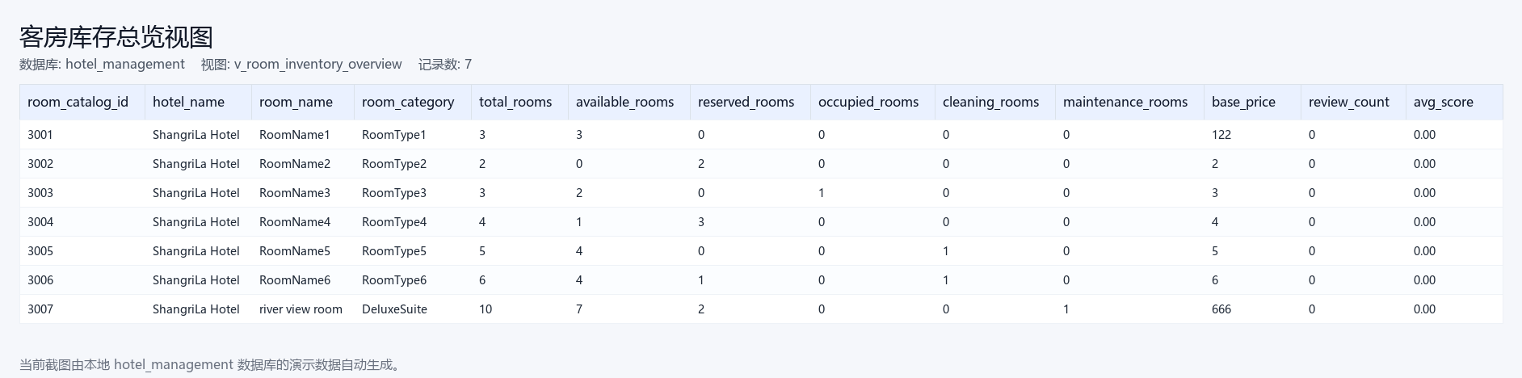
图 7 客房库存视图
- 客房日常状态视图（v_room_daily_status）
CREATE VIEW `v_room_daily_status` AS
SELECT ri.id AS room_id, ri.room_no, ri.floor_no, ri.status AS current_status,
rc.kefangmingcheng AS room_name, rc.room_category, br.booking_id AS active_booking_id,
bo.yudingbianhao AS booking_no, bo.customerming AS customer_name,
cr.id AS active_checkin_id, cr.checkin_time, cr.checkout_time,
ht.id AS active_housekeeping_task_id, mr.id AS active_maintenance_id,
CASE WHEN cr.id IS NOT NULL AND cr.status='checked_in' THEN 'occupied_by_checkin'
WHEN mr.id IS NOT NULL AND mr.maintenance_status IN ('reported','processing') THEN 'maintenance_processing'
WHEN ht.id IS NOT NULL AND ht.task_status IN ('pending','assigned','in_progress') THEN 'cleaning_processing'
WHEN br.id IS NOT NULL AND br.room_status IN ('reserved','checked_in') THEN 'reserved_by_booking'
ELSE ri.status END AS business_status
FROM `room_instance` ri JOIN `room_catalog` rc ON rc.id=ri.room_catalog_id
LEFT JOIN `booking_room` br ON br.room_id=ri.id AND br.room_status IN ('reserved','checked_in')
LEFT JOIN `booking_order` bo ON bo.id=br.booking_id AND bo.booking_status IN ('created','reserved','checked_in')
LEFT JOIN `checkin_record` cr ON cr.room_id=ri.id AND cr.status='checked_in'
LEFT JOIN `housekeeping_task` ht ON ht.room_id=ri.id AND ht.task_status IN ('pending','assigned','in_progress')
LEFT JOIN `maintenance_record` mr ON mr.room_id=ri.id AND mr.maintenance_status IN ('reported','processing');

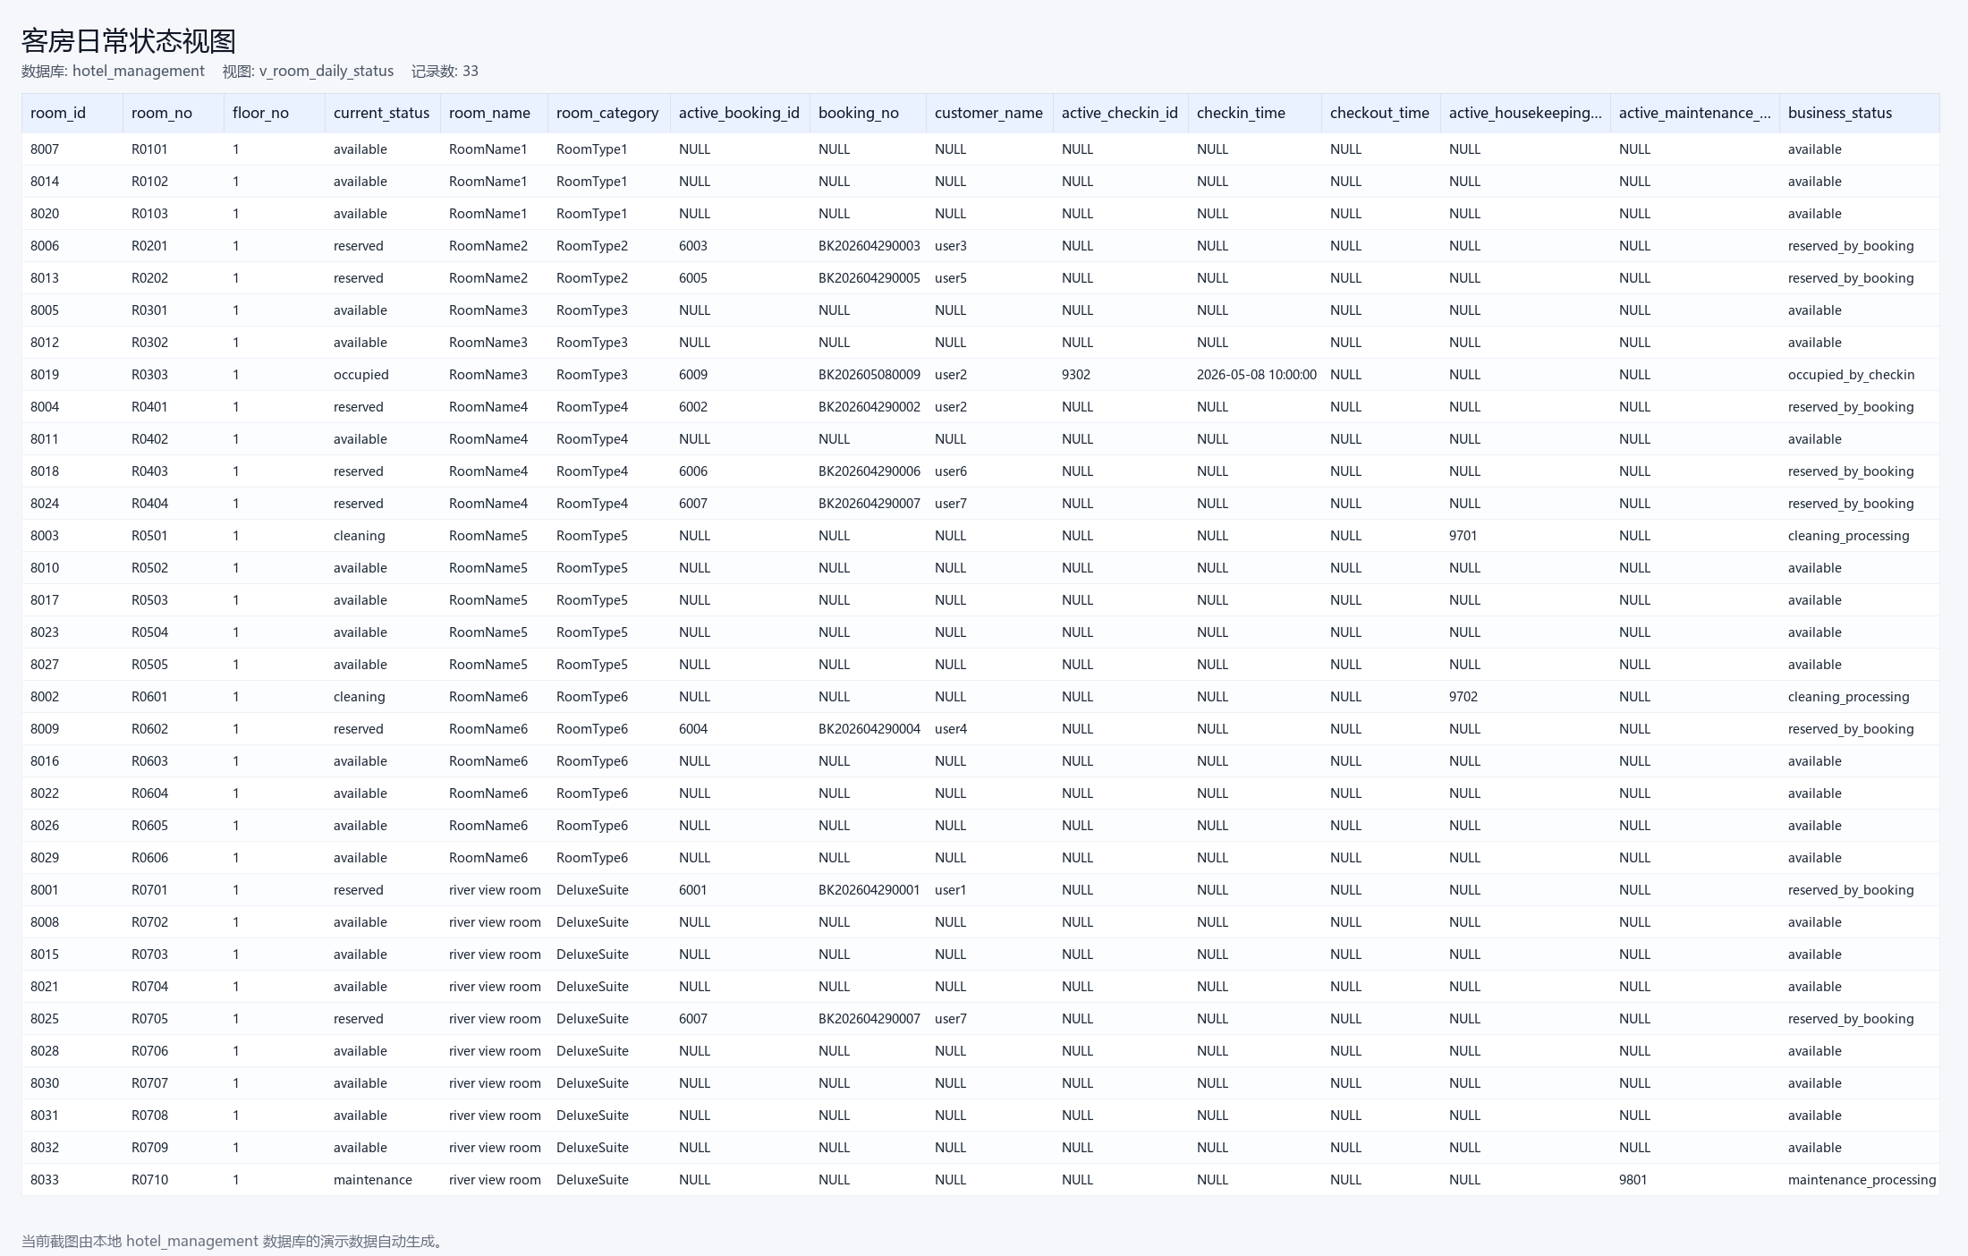
图 8 客房日常状态视图
- 预定明细视图（v_booking_detail）
CREATE VIEW `v_booking_detail` AS
SELECT bo.id AS booking_id, bo.yudingbianhao AS booking_no, bo.addtime AS booking_time,
bo.customerming AS customer_login_name, COALESCE(bo.customer_id,c.id) AS customer_id, c.xingming AS customer_real_name,
c.shoujihao AS customer_phone, bo.kefangmingcheng AS room_name, bo.room_category,
GROUP_CONCAT(DISTINCT ri.room_no ORDER BY ri.room_no SEPARATOR ',') AS room_numbers,
bo.expected_checkin_date, bo.expected_checkout_date,
bo.kefangjiage AS unit_price, bo.shuliang AS quantity, bo.zongjine AS total_amount,
bo.ispay AS old_payment_status, bo.booking_status, COUNT(DISTINCT bsl.id) AS status_change_count,
MAX(bsl.created_at) AS last_status_time
FROM `booking_order` bo
LEFT JOIN `customer` c ON c.id=bo.customer_id OR (bo.customer_id IS NULL AND c.customerming=bo.customerming)
LEFT JOIN `booking_room` br ON br.booking_id=bo.id
LEFT JOIN `room_instance` ri ON ri.id=br.room_id
LEFT JOIN `booking_status_log` bsl ON bsl.booking_id=bo.id
GROUP BY bo.id, bo.yudingbianhao, bo.addtime, bo.customerming, bo.customer_id, c.id, c.xingming, c.shoujihao,
bo.kefangmingcheng, bo.room_category, bo.expected_checkin_date, bo.expected_checkout_date,
bo.kefangjiage, bo.shuliang, bo.zongjine, bo.ispay, bo.booking_status;

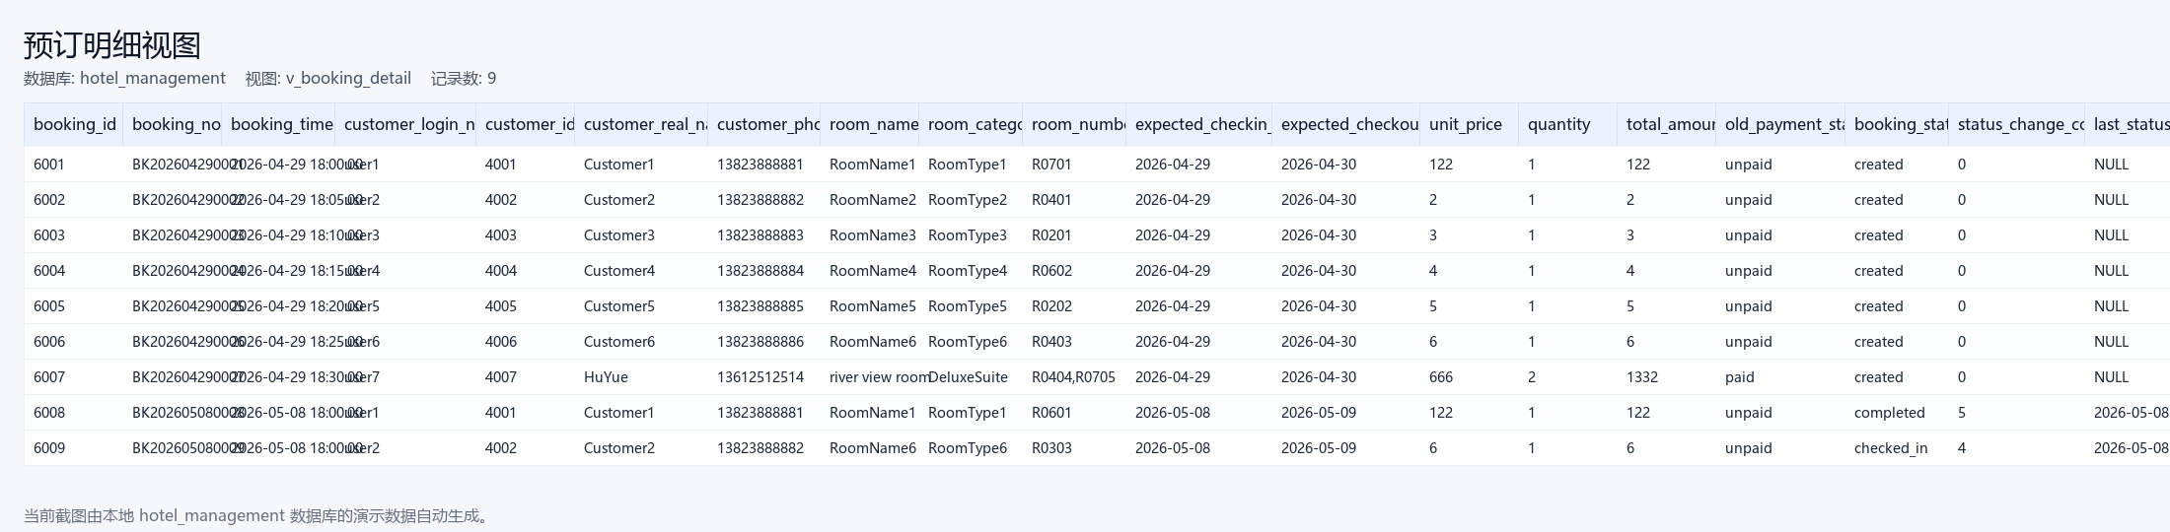
图 9 预定明细视图
- 入住客人明细视图（v_checkin_guest_detail）
CREATE VIEW `v_checkin_guest_detail` AS
SELECT cr.id AS checkin_id, cr.booking_id, cr.customer_id, c.xingming AS customer_name,
ri.room_no, rc.kefangmingcheng AS room_name, rc.room_category, cr.checkin_time,
cr.checkout_time, cr.status AS checkin_status,
MAX(CASE WHEN cg.is_primary=1 THEN cg.guest_name END) AS primary_guest_name,
COUNT(cg.id) AS guest_count, e.employeexingming AS employee_name
FROM `checkin_record` cr JOIN `room_instance` ri ON ri.id=cr.room_id JOIN `room_catalog` rc ON rc.id=ri.room_catalog_id
LEFT JOIN `customer` c ON c.id=cr.customer_id LEFT JOIN `employee` e ON e.id=cr.employee_id
LEFT JOIN `checkin_guest` cg ON cg.checkin_id=cr.id
GROUP BY cr.id, cr.booking_id, cr.customer_id, c.xingming, ri.room_no, rc.kefangmingcheng, rc.room_category,
cr.checkin_time, cr.checkout_time, cr.status, e.employeexingming;

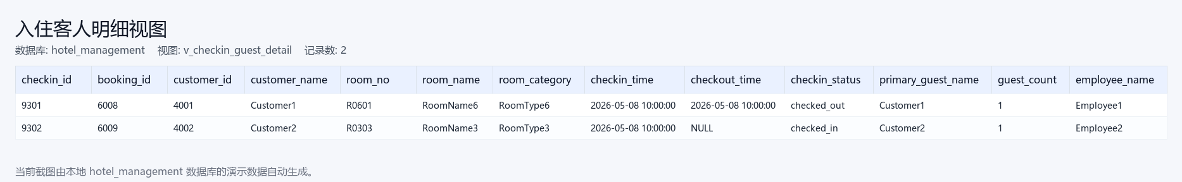
图 10 入住客人明细视图
- 账单支付汇总视图（v_bill_payment_summary）
CREATE VIEW `v_bill_payment_summary` AS
SELECT b.id AS bill_id, b.booking_id, b.checkin_id, b.customer_id, c.xingming AS customer_name,
b.room_amount, b.service_amount, b.discount_amount, b.payable_amount,
COALESCE(SUM(CASE WHEN pr.pay_status='success' THEN pr.pay_amount ELSE 0 END),0) AS actual_paid_amount,
COALESCE(SUM(CASE WHEN rr.refund_status='success' THEN rr.refund_amount ELSE 0 END),0) AS actual_refund_amount,
b.status AS bill_status, MAX(pr.paid_at) AS last_paid_at, b.created_at
FROM `bill` b LEFT JOIN `customer` c ON c.id=b.customer_id
LEFT JOIN `payment_record` pr ON pr.bill_id=b.id LEFT JOIN `refund_record` rr ON rr.payment_id=pr.id
GROUP BY b.id, b.booking_id, b.checkin_id, b.customer_id, c.xingming, b.room_amount, b.service_amount,
b.discount_amount, b.payable_amount, b.status, b.created_at;

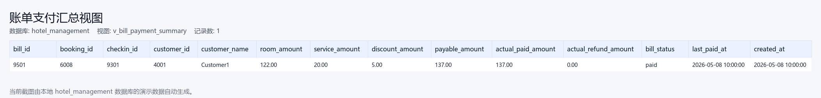
图 11 账单支付汇总视图
- 月度营收统计视图（v_monthly_revenue_report）
CREATE VIEW `v_monthly_revenue_report` AS
SELECT DATE_FORMAT(pr.paid_at,'%Y-%m') AS revenue_month, rc.room_category, pr.pay_method,
COUNT(DISTINCT b.id) AS bill_count, COUNT(pr.id) AS payment_count,
SUM(CASE WHEN pr.pay_status='success' THEN pr.pay_amount ELSE 0 END) AS gross_revenue,
COALESCE(SUM(CASE WHEN rr.refund_status='success' THEN rr.refund_amount ELSE 0 END),0) AS refund_amount,
SUM(CASE WHEN pr.pay_status='success' THEN pr.pay_amount ELSE 0 END)-COALESCE(SUM(CASE WHEN rr.refund_status='success' THEN rr.refund_amount ELSE 0 END),0) AS net_revenue
FROM `payment_record` pr JOIN `bill` b ON b.id=pr.bill_id
LEFT JOIN `checkin_record` cr ON cr.id=b.checkin_id LEFT JOIN `room_instance` ri ON ri.id=cr.room_id
LEFT JOIN `room_catalog` rc ON rc.id=ri.room_catalog_id LEFT JOIN `refund_record` rr ON rr.payment_id=pr.id
GROUP BY DATE_FORMAT(pr.paid_at,'%Y-%m'), rc.room_category, pr.pay_method;

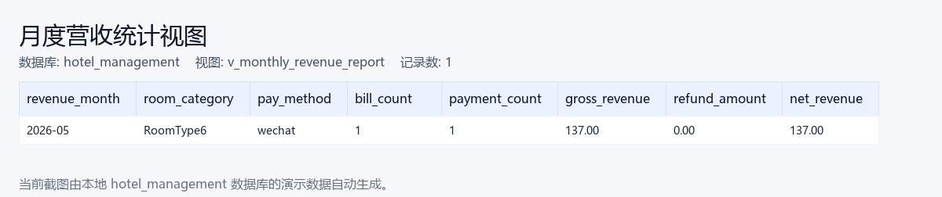
图 12 月度营收统计视图
- 员工业务汇总视图（v_employee_operation_summary）
CREATE VIEW `v_employee_operation_summary` AS
SELECT e.id AS employee_id, e.employeegonghao AS employee_no, e.employeexingming AS employee_name,
COUNT(DISTINCT ol.id) AS total_operations,
COUNT(DISTINCT CASE WHEN ol.business_type='booking_order' THEN ol.id END) AS booking_operations,
COUNT(DISTINCT CASE WHEN ol.business_type='checkin_record' THEN ol.id END) AS checkin_operations,
COUNT(DISTINCT CASE WHEN ol.business_type='bill' THEN ol.id END) AS bill_operations,
COUNT(DISTINCT CASE WHEN ol.business_type='refund_record' THEN ol.id END) AS refund_operations,
COUNT(DISTINCT ht.id) AS cleaning_task_count,
COUNT(DISTINCT mr.id) AS maintenance_task_count,
MAX(ep.total_score) AS latest_assessment_score,
MAX(ep.grade) AS latest_assessment_grade,
MIN(ol.created_at) AS first_operation_time, MAX(ol.created_at) AS last_operation_time
FROM `employee` e LEFT JOIN `operation_log` ol ON ol.operator_type='employee' AND ol.operator_id=e.id
LEFT JOIN `housekeeping_task` ht ON ht.assigned_employee_id=e.id AND ht.task_status='completed'
LEFT JOIN `maintenance_record` mr ON mr.handled_by_employee_id=e.id AND mr.maintenance_status='completed'
LEFT JOIN `employee_performance` ep ON ep.employee_id=e.id
GROUP BY e.id, e.employeegonghao, e.employeexingming;

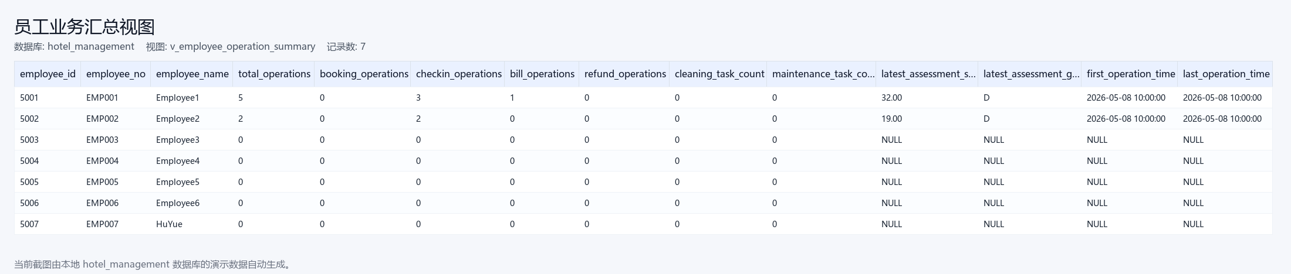
图 13 员工业务汇总视图
- 客户价值画像视图（v_customer_value_profile）
CREATE VIEW `v_customer_value_profile` AS
SELECT c.id AS customer_id, c.customerming AS customer_login_name, c.xingming AS customer_name, c.shoujihao AS customer_phone,
COUNT(DISTINCT bo.id) AS booking_count, COUNT(DISTINCT cr.id) AS checkin_count,
COALESCE(SUM(DISTINCT b.payable_amount),0) AS total_payable_amount,
COALESCE(SUM(DISTINCT b.paid_amount),0) AS total_paid_amount,
COUNT(DISTINCT f.id) AS favorite_count, COUNT(DISTINCT rr.id) AS room_review_count,
COUNT(DISTINCT hr.id) AS hotel_review_count, MAX(bo.addtime) AS last_booking_time
FROM `customer` c LEFT JOIN `booking_order` bo ON bo.customerming=c.customerming
LEFT JOIN `checkin_record` cr ON cr.customer_id=c.id LEFT JOIN `bill` b ON b.customer_id=c.id
LEFT JOIN `favorite` f ON f.userid=c.id LEFT JOIN `room_review` rr ON rr.userid=c.id LEFT JOIN `hotel_review` hr ON hr.userid=c.id
GROUP BY c.id, c.customerming, c.xingming, c.shoujihao;

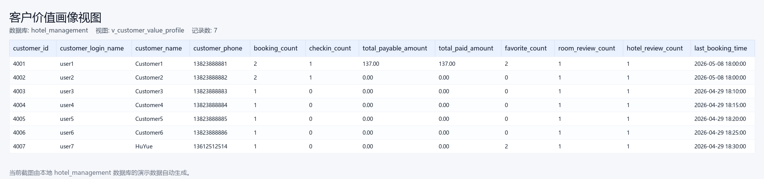
图 14 客户价值画像视图
- 客房清扫任务视图（v_housekeeping_task_detail）
CREATE VIEW `v_housekeeping_task_detail` AS
SELECT ht.id AS task_id, ht.task_type, ht.task_status, ht.scheduled_time, ht.completed_time,
ri.room_no, ri.status AS room_status, rc.kefangmingcheng AS room_name, rc.room_category,
cr.booking_id, e.employeexingming AS assigned_employee_name, ht.remark, ht.created_at
FROM `housekeeping_task` ht
JOIN `room_instance` ri ON ri.id=ht.room_id
JOIN `room_catalog` rc ON rc.id=ri.room_catalog_id
LEFT JOIN `checkin_record` cr ON cr.id=ht.checkin_id
LEFT JOIN `employee` e ON e.id=ht.assigned_employee_id;

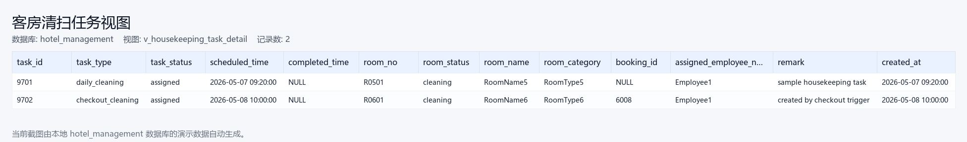
图 15 客房清扫任务视图
- 员工考核明细视图（v_employee_performance_detail）
CREATE VIEW `v_employee_performance_detail` AS
SELECT ep.id AS performance_id, ep.employee_id, e.employeegonghao AS employee_no,
e.employeexingming AS employee_name, ep.period_start, ep.period_end,
ep.checkin_count, ep.bill_count, ep.payment_count, ep.cleaning_count,
ep.maintenance_count, ep.operation_count, ep.manager_score, ep.total_score,
ep.grade, assessor.employeexingming AS assessor_name, ep.created_at
FROM `employee_performance` ep
JOIN `employee` e ON e.id=ep.employee_id
LEFT JOIN `employee` assessor ON assessor.id=ep.assessor_id;

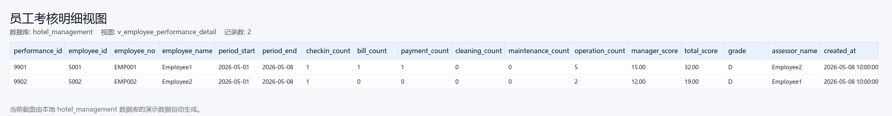
图 16 员工考核明细视图

